# Supplemental Staff Report

Meeting Date: August 2, 2022

To: Siskiyou County Board of Supervisors

From: Bernadette Cizin, Assistant Planner

Subject: Proposed Matthew & Audrey Parsons Trust Agricultural Preserve Amendment, Williamson Act Rescission and Re-entry (APA-22-02) and CEQA Determination

Exhibits: A. Rules for the Establishment and Administration of Agricultural Preserves and Williamson Act Contracts

## Background and Discussion

The Williamson Act, also known as the California Land Conservation Act of 1965, enables local governments to enter into contracts with private landowners for the purpose of restricting specific parcels of land to agricultural or related open space use. In return, landowners receive property tax assessments which are much lower than normal because they are based upon agricultural uses as opposed to full market value.

The Williamson Act is a means to restrict the uses of agricultural and open space lands to farming and ranching uses during the length of the contract period. The Williamson Act Program was also envisioned as a way for local governments to integrate the protection of open space and agricultural resources into their overall strategies for planning urban growth patterns. To this end, three principal objectives were originally outlined:

* Protection of Agricultural Resources
* Preservation of Open Space Land
* Promotion of Efficient Growth Patterns

Participating counties and cities are required to establish their own rules and regulations regarding implementation of the Act within their jurisdiction. These rules include but are not limited to: enrollment guidelines, acreage minimums, enforcement procedures, allowable uses, and compatible uses.

The Williamson Act Guidelines for Siskiyou County have relatively remained unchanged throughout the duration of the program. There was a minor amendment in 2020 which removed the requirement of maintaining an agricultural preserve advisory board. The defined agricultural uses, compatible uses, and other Williamson Act criteria have not been updated since 2011. The guidelines do not have clear definitions of uses or terminology.

On June 14, 2022, staff brought before the board a proposed Agricultural Preserve amendment to bring approximately 525 acres, owned by Matthew & Audrey Parsons Trust, under one individual preserve and a single Williamson Act contract. The property is primarily used for row and field crops and uses such as the residence of the property owners, farm employee housing and accessory structures. Staff recommended that the board not approve the request as there is an open code compliance case on one of the subject parcels. After board discussion and comment by the applicant, the public hearing was continued to today’s date.

**Code Enforcement Case**  
Code enforcement officers have revisited the site since the June hearing. It appears that progress is being made on the removal of the logs by processing and preparing for sale. It also appears that some of the commercially produced wood pellets have been removed however it is difficult to know how much remains as their observations were from the County Road Right-of-Way.

The last report by the property owners was that they continue to work on removing the firewood processing business. They also continue to work towards the removal of the stored commercially produced wood pellets. They anticipate having the commercial wood pellets, firewood processing and storage off of the site by February of 2023.

**Options to Continue the Business**

Staff and the property owners have had several discussions on how they can continue the wood processing and firewood sales. There are two primary reasons why the current location of the wood processing site along with the storage of the commercially produced wood pellets is not allowed.

**Zoning** – The site zoned Prime Agricultural which does not allow for processing facilities of any type, nor does it allow for bulk commercial storage.

**Williamson Act Rules** – Only Wood processing facilities for timber which timber was grown and harvested on the contracted property is considered an Agricultural Production. No wood processing facilities are considered a Compatible Use (Rules Section IV)

Staff has attempted to find a path for the Parsons to continue the business on their land with the current zoning and Williamson Act Contract restrictions. The following options have been discussed with the property owners, none of which they consider to be a viable option for them.

Option 1.

Apply with the County to -

1. Rezone a portion of property (approximately 5 acres) where the processing site is from AG-1 to AG-2.
2. Divide 40 acres containing the business from the existing parcel.
3. Obtain a Use Permit to allow for a wood processing facility and bulk storage at the existing site.
4. Cancel the Williamson Act Contract on these 40 acres.

Option 2.

Apply with the County to -

1. Relocate the business to an area on their property which is zoned AG-2.
2. Divide 40-acres containing this AG-2 area from the existing parcel.
3. Obtain a Use Permit to allow their business on this 40-acres.
4. Cancel the Williamson Act Contract on these 40-acres.

Option 3.

Apply with the County to -

1. Cancel the contract for the entire parcel on which the business is located.
2. Rezone the area where the business is from AG-1 to AG-2.
3. Obtain a Use Permit.

Option 4.

Apply with the County to -

1. Cancel the contract for the entire parcel on which the business is located.
2. Relocate the business to an area that is zoned AG-2.
3. Obtain a Use Permit.

**Possible Update to County Rules**

Should the County consider updating the local Rules, the board could consider the addition of a Compatible Use to allow for the processing and storage of Agricultural Commodities that have been grown or produced off site. Also, restricting the area for this allowed use and requiring a compatibility review by the Agricultural Preserve Administrator prior to the establishment of the proposed use.

**Contracts**

APNs 010-010-630 and 010-010-660 are under Contract #73020. Even though there is an active code compliance case, staff which staff would not recommend the issuance of a Notice of Non-Renewal as the owners are actively working to remedy the compliance issues.

APN’s 010-010-550 and 002-170-270 are currently in the Non-Renewal process under Contract #76033NR due to the non-compliance of a separate property owner under the same contract.

**Agricultural Preserve**  
The subject parcels are located within two different Agricultural Preserves.

If the code enforcement issue were resolved and should the Board approve the applicant’s request, the Parsons Trust will own all of the property under one particular agricultural preserve as shown in Figure 1 of this report.

**Williamson Act Contract Rescission and Re-entry**  
APN 010-010-660 and a portion of 010-010-660 is under contract No. 73020 as recorded in the Siskiyou County Official Records as Document No 05-0001313 on January 24, 2005. The remainder of 010-010-660 was later included in Contract No. 73020 by Agricultural Preserve Contract Amendment APA-00-06.

APN 002-170-270 and 010-010-550 are under contract recorded in the Siskiyou County Official Records at Volume 750 Page 283 on February 17, 1976.

If the code enforcement issue were resolved and should the Board approve the applicant’s request, the Parsons Trust will own all of the property under one particular Williamson Act Contract as shown in Figure 1 of this report.

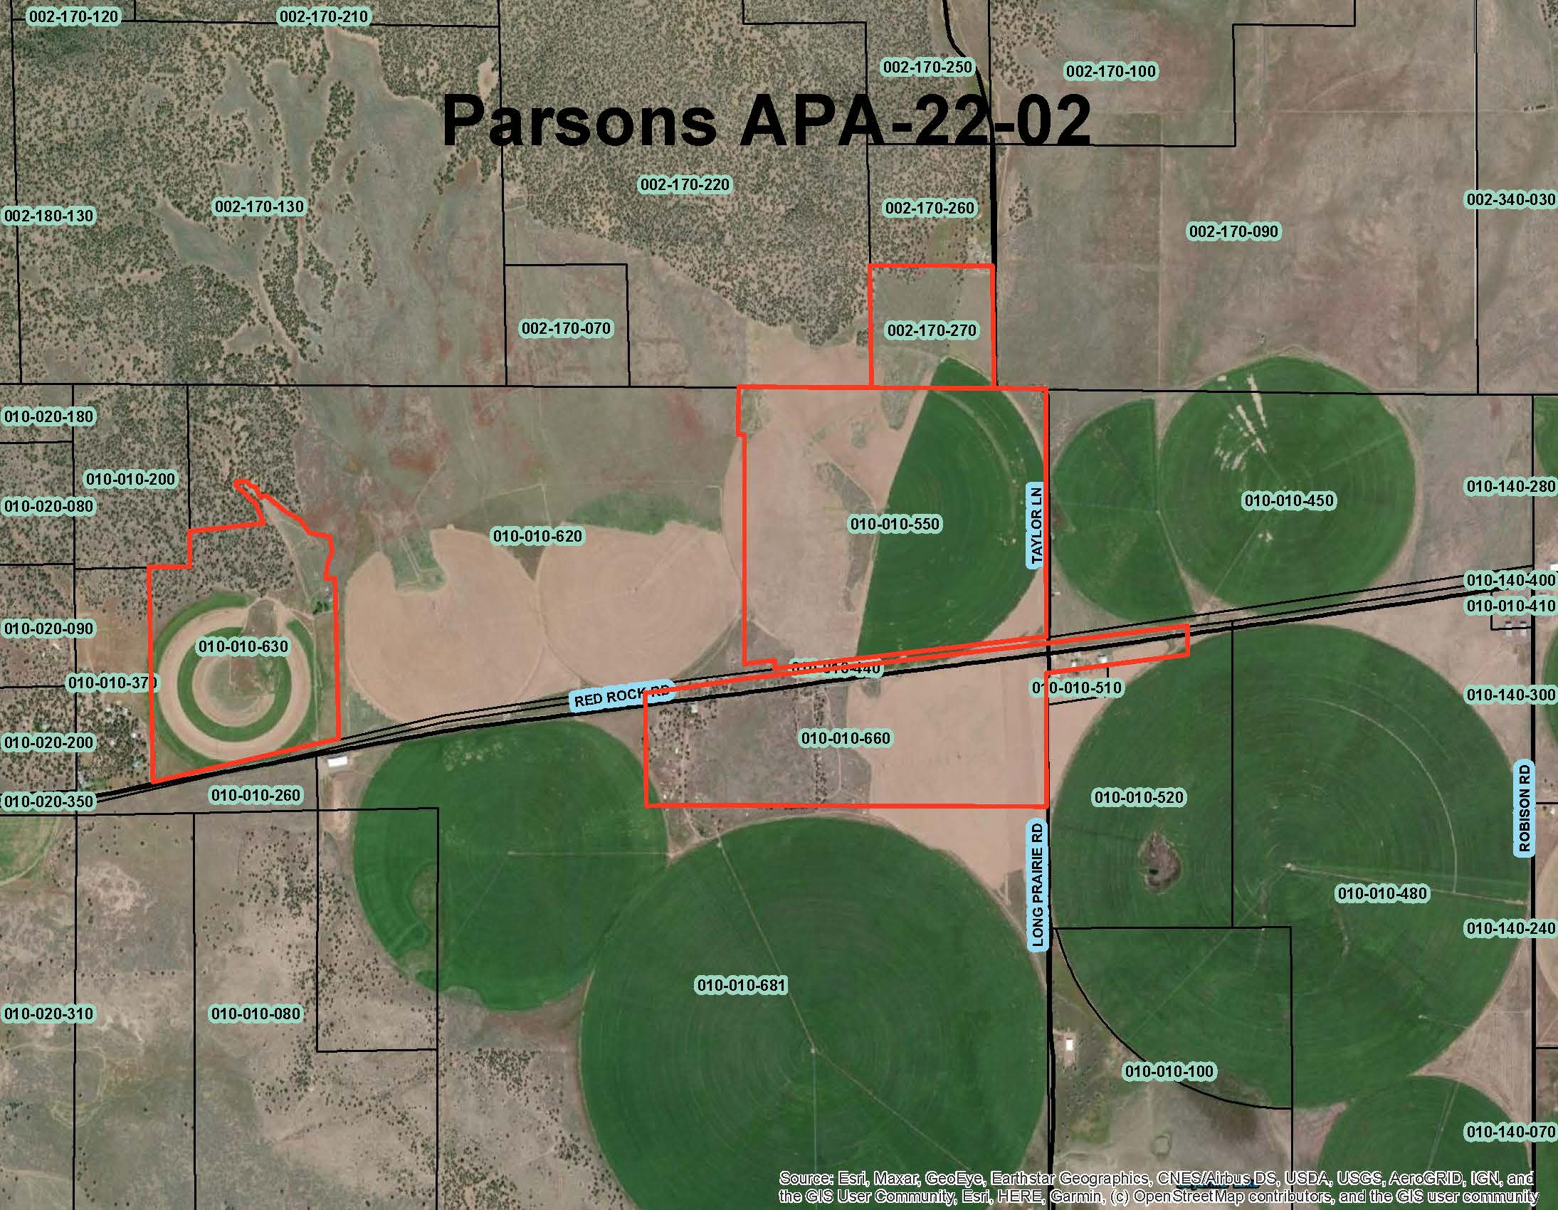  
Figure 1: Subject Parcels

## Environmental Review

Staff is proposing that the proposed project be considered categorically exempt from the California Environmental Quality Act (CEQA) pursuant to CEQA Guidelines Section 15317, *Open Space Easements or Contracts.* A Categorical Exemption implies that the project will not result in any significant adverse environmental effects. CEQA Guidelines Section 15317 specifically exempts the making and renewing of open space contracts under the Williamson Act, which is applicable to the subject action.

The Board of Supervisors must consider the proposed CEQA exemption together with any comments received during the public review process. Further, the exemption can only be approved if the Board finds, based on the whole record before it, that there is not substantial evidence that the project will have a significant effect on the environment. Accordingly, a finding to this effect has been incorporated into both draft resolutions prepared for the Board’s consideration.

## Comments

Notice of the project was published and posted as required prior to the Board of Supervisors meeting and no public comment was received as of the preparation of this staff report.

## Recommended Action

Should the Board of Supervisors concur with staff’s analysis, as the Zoning Code and Williamson Act Rules are currently written, staff recommends that the Board of Supervisors continue the public hearing to give the property owners the opportunity to return the property to compliance with County Code and the Rules for the Establishment and Administration of Agricultural Preserves and Williamson Act Contracts.

and

Should the Board of Supervisors wish to update the County Rules to include additional compatible uses, staff recommends that the Board of Supervisors continue the public hearing to allow staff time to make recommended changes to the and bring the updated Rules to the board for their review and approval .

## Recommended Motions

I move to take the following actions:

1. Direct staff to bring the proposed project to the board for consideration upon compliance with Siskiyou County code and the “Rules for the Establishment and Administration of Agricultural Preserves and Williamson Act Contracts”.
2. Direct staff to update the County’s Williamson Act Guidelines to better define agricultural uses and compatible uses.