Code Enforcement – Notice to Comply

Code Enforcement Site Visit 1/12/2022 Photograph 1 – stockpile of logs to be processed into firewood

Code Enforcement Site Visit 1/12/2022 Photograph 2 – firewood “towers”

Code Enforcement Site Visit 1/12/2022 Photograph 3 – firewood processing equipment

Code Enforcement Site Visit 1/12/2022 Photograph 4 – firewood processing equipment

Code Enforcement Site Visit 1/12/2022 Photograph 5 – stock of wood pellets

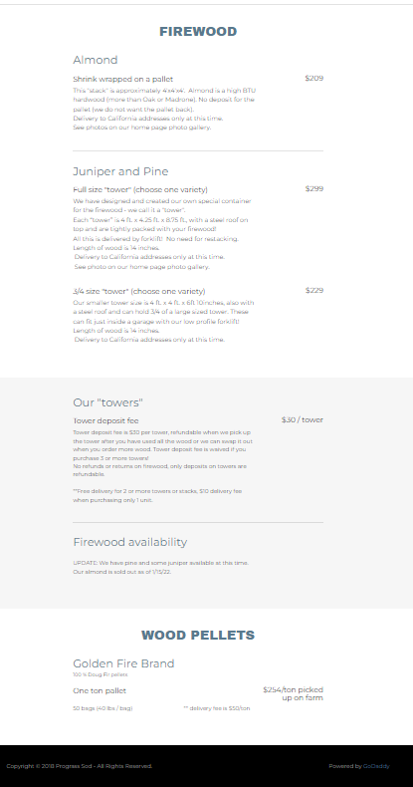   
Image from business website (taken 5/26/2022)