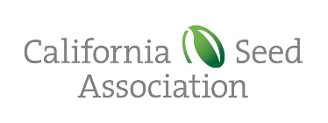

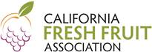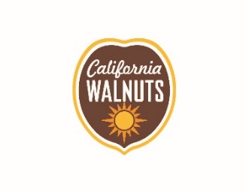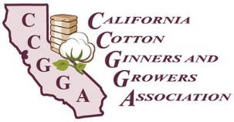

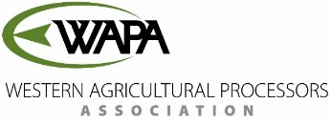

May 3, 2022

The Honorable Steve Bennett

California State Assembly

1021 O Street, Ste. 4140

Sacramento, CA 95814

**SUBJECT: AB 2201 (BENNETT) GROUNDWATER SUSTAINABILITY AGENCY: GROUNDWATER EXTRAXTION PERMIT: VERIFICATION**

**OPPOSE – AS AMENDED APRIL 27, 2022**

Dear Mr. Bennett:

The undersigned organizations must respectfully **OPPOSE AB 2201** because this bill restricts the water available for agriculture and restricts the local control of groundwater previously guaranteed by the Sustainable Groundwater Management Act (SGMA).

**SGMA’s Policy of Local Control**

When SGMA was signed into law in 2014, California was in the midst of a historic drought. The 2011–2017 drought consisted of the driest period in California’s recorded history. In creating SGMA, lawmakers and the governor not only contemplated a drought situation such as what we have today, drought was on the front of their minds and was part of the policy discussions of SGMA at every step in the legislative process. Coming out of that public policy debate was consensus support for local control.

Then-Governor Brown stated that “Groundwater management in California is best accomplished locally.” Additionally, in enacting SGMA, Section 113 was added to the Water Code stating, “It is the policy of the state that groundwater resources be managed sustainably for long-term reliability and multiple economic, social, and environmental benefits for current and future beneficial uses. Sustainable groundwater management is best achieved locally through the development, implementation, and updating of plans and programs based on the best available science.”

AB 2201 is at odds with this stated policy of local control. Instead, AB 2201 would create a new permitting process for groundwater wells that will negatively impact agricultural businesses, and rural communities that rely on a thriving agricultural economy for their livelihoods, and food security. This bill imposes a strict new mandate on how groundwater sustainability agencies (or GSAs) must operate and manage their own groundwater basins. Rather than allowing GSAs to determine which management options are best suited for local conditions, this bill would require that GSAs make specific findings related to new groundwater wells before a county could authorize such a well.

It is important to note that GSAs currently possess the authority to manage groundwater and impose restrictions on groundwater extraction and use. The difference is that each and every GSA is not *required* to make the same specific findings in the manner prescribed by AB 2201. In that sense, the bill imposes a state mandate and circumvents local control. SGMA acknowledges that not every groundwater basin is the same, and that no single management solution is the right fit for every basin. AB 2201 does not afford GSAs the necessary flexibility to tailor management to local conditions as required under SGMA.

SGMA was, and is, an historic law at an historic time. The repeatedly stated executive and legislative intent, adopted in good faith by the many engaged stakeholders, is to abide by and fulfill the SGMA’s meticulously and, in some cases, painfully crafted terms. SGMA must be allowed to follow and to complete at least the initial statutory terms and timelines. To re-open any law before it is fully implemented is not sound public policy. In this case, re-opening a carefully negotiated statute adds uncertainty and avenues of potentially critical disputes in a layered and foundational area of water law. We should continue collaborating.

**SGMA is Being Implemented and Limiting Groundwater Use**

Even without this bill, SGMA is anticipated to result in the fallowing of up to 1 million acres of farmland in the San Joaquin Valley over the next few decades, which will result in the loss of 85,000 jobs and cost billions in lost farm revenue. This bill will only exacerbate these impacts. Additionally, California agriculture provides necessary food supplies to the state and the rest of the nation. At a time when prices are rising due to inflation and surface water supplies are essentially unavailable for agriculture, further limiting water supply for crops means that Californians may have an even harder time accessing affordable and locally-grown products.

**AB 2201 is Untimely**

Finally, Governor Newsom issued Executive Order N-7-22 on March 28, 2022, which imposes substantially similar requirements on counties and GSAs related to new well permitting. Counties and GSAs are currently struggling to determine how to best implement the Executive Order’s requirements. Keep in mind that the Executive Order is tied to the declaration of a drought emergency. Thus, the Executive Order may address current drought concerns, but is not a permanent change in law. AB 2201 would codify the Executive Order at a time when it is not appropriate.

Rather, counties, GSAs, and water users should be able to work through the implementation of the Executive Order’s directives on a temporary, emergency basis before codifying the approach and modifying the local control guaranteed in SGMA. Wouldn’t it be prudent to analyze and then determine the potential success of, and problems associated with, the Executive Order before codifying it on a permanent basis? It is not the right time for this bill.

**AB 2201 Reaches Even Sustainable Basins and Presents Litigation Risks**

This bill creates mandates for all medium- and high-priority basins; it is not limited to those basins subject to critical overdraft. SGMA treats critically overdrafted basins differently than other medium- or high-priority basins, the vast majority of which are being sustainably managed. The process for prioritizing basins is based more on population and the relative reliance on groundwater for water supply than how sustainably the basin is managed.

AB 2201 requires a GSA to determine that a new or altered well will not impact other nearby wells or cause subsidence that impacts nearby infrastructure. This is difficult if not impossible to assess. This requirement goes far beyond the Executive Order. SGMA already authorizes a GSA to impose spacing requirements on new wells to minimize well interference, to control groundwater extractions, and to regulate the construction of new wells. (Wat. Code, § 10726.4).

This bill also requires a GSA to allow for a 30-day public comment period before making a determination about a proposed new well. This makes all permit actions *de facto* discretionary, which either add a new duplicative public comment process to those already established under CEQA or would make well permitting decisions subject to CEQA themselves. In all, this increases the risks for litigation, both within the CEQA context and in relation to groundwater

adjudication proceedings.

We appreciate the severity of the drought and the effects of that drought on all of us. However, we must respectfully **OPPOSE AB 2201** as it circumvents SGMA and imposes mandates that have not been developed with sufficient consideration of unintended consequences or evaluation of effectiveness of the Executive Order.

Sincerely,

Brenda Bass

Policy Advocate

California Chamber of Commerce

Almond Alliance of California

California Association of Winegrape Growers

California Chamber of Commerce

California Farm Bureau Federation

California League of Food Producers

Western Growers Association

Agricultural Council of California

Valley Ag Water Coalition

African American Farmers of California

California Cotton Ginners and Growers Association

California Fresh Fruit Association

California Grain and Feed Association

California Pear Growers Association

California Seed Association

California Walnut Commission

Nisei Farmers League

Western Agricultural Processors Association

Western Plant Health Association

Wine Institute

BB:am