Staff Report
Meeting Date: April 19, 2022
To: Siskiyou County Board of Supervisors
From: Bernadette Cizin, Planner
Subject: Proposed Zone Change (Z-20-07) Amending Zoning District Map 10-6.205-284, Menne Agricultural Preserve Amendment, Williamson Act Contract Rescission and Reentry (APA-21-02) and CEQA Determination

Background
On September 9, 2021, the County received an application for a Boundary Line Adjustment (BLA-21-31) proposing the transfer of approximately 288 acres between two parcels currently owned by Menne Family Partners, L.P. The project site is located south of Scott River Road, approximately five miles west of the town of Fort Jones on APNs 014-130-370, 014-130-390, 014-130-490, 014-361-380, 014-361-460, and 014-361-470; Township 44 North, Range 9 West, Sections 29 and 30.
This Boundary Line Adjustment is complicated by the fact that a small portion of property, approximately 2 acres of gravely hillside, is zoned Prime Agriculture with an 80-acre minimum parcel size. The prime agricultural zoning in this particular area follows the Scott Valley Area Plan mapping of Prime Agricultural Soils, rather than the actual conditions and uses of the land. The USDA soils mapping and data show the area to is not prime farmland (Exhibit D of Planning Commission Staff Report) and the Siskiyou County General Plan shows it is not within Land Use Policy Prime Agricultural Soils. An evaluation by the local UC Cooperative Extension Agronomy Advisor (Exhibit C of Planning Commission Staff Report) confirmed that this is not prime agriculture farmland. Upon notification that a Zone Change would be required, the applicant opted to include an adjacent undeveloped property, APN 014-361-420 to the project even though it is not a part of the boundary line adjustment, as it also has 2 acres included in the mapping error.
The project was further complicated by the fact that the property is located in different agricultural preserves and are under two separate Williamson Act contracts. In order for the BLA to be recorded, the Board needs to first correct the mapping error by approving the rezone (Z-22-02) from Prime Agricultural, 80-acre minimum parcel size (AG-1-B-80) to Rural Residential Agricultural, 10-acre minimum parcel size (R-R-B-10) and then approve the proposed Agricultural Preserve Amendment and Williamson Act Contract Rescission and Reentry (APA-21-02).
Agricultural Preserve
The subject parcels are located in two separate Agricultural Preserves.
APNs 014-130-490, 014-361-380, 014-361-460 and 014-361-470 are together in a preserve as established on February 8, 1973, per Board of Supervisors Resolution 119 Book 5 along with another parcel, APN 014-100-100 also currently owned by Menne Family Partners, L.P.
APNs 014-130-370 and 014-130-390 are together in a preserve originally recorded in Siskiyou County Official Records in Volume 621 at Page 429 on May 5, 1971. This preserve was modified on March 16, 2018 by Board of Supervisors Resolution No. 18-26 under application APA-16-01 to reconfigure the preserves upon the recording of Boundary Line Adjustment BLA-16-07.
Upon approval of APA-21-02 and simultaneous recording with the BLA, Resultant Parcels A and B and APN 014-100-100 would be under one 445.5-acre Agricultural Preserve. APNs 014-130-550 and 014-130-560 would be under one 681.77-acre Agricultural Preserve.
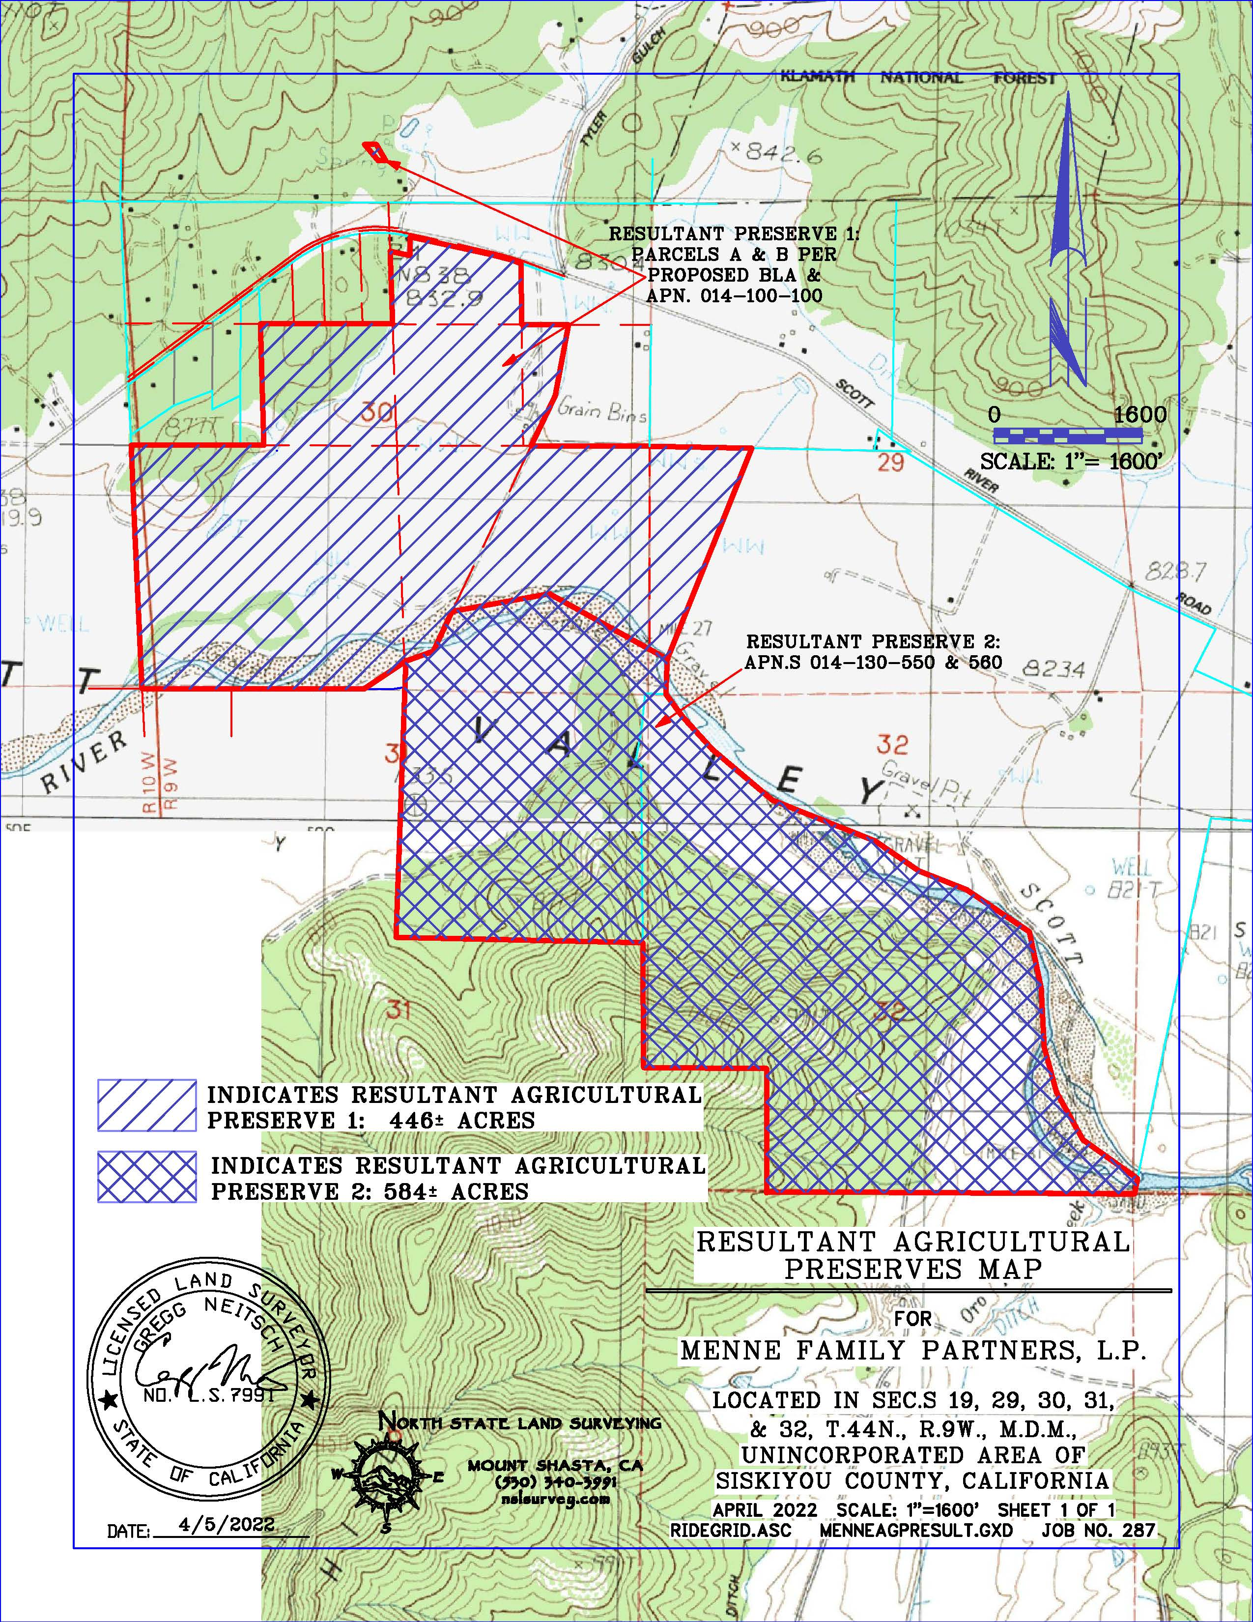
Figure 2: Proposed Agricultural Preserve Exhibit Map

Williamson Act Contract Rescission and Re-entry
The 288 acres to be transferred via the proposed BLA are currently under Williamson Act Contract No. 167, as recorded in Siskiyou County Official Records in Volume 682 at Page 600. The legal parcel that the 288 acres is proposed to be transferred to is currently under Williamson Act Contract No. APA-16-01-A as recorded in Siskiyou County Official Records Document 2019-0004438. In order to allow the proposed BLA to be administratively approved, the existing Williamson Act contracts would need to be rescinded and reissued under new contracts.
Upon approval of APA-21-02 and simultaneous recording with the BLA, the applicant would have approximately 52 acres, Resultant Parcel A, in one contract and approximately 393.5 acres, Resultant Parcel B and APN 014-100-100, in a second contract. APNs 014-130-550 and 014-130-560 will remain together under a third contract. The proposed new Williamson Act contracts comply with the minimum parcel size requirements pursuant to Government Code Section 51222.
Government Code Section 51230 and the County’s Williamson Act Guidelines require that agricultural preserves be a minimum of 100 acres. The proposed new agricultural preserves would comply with both State and County agricultural preserve requirements. Additionally, the proposed new Williamson Act contracts comply with the minimum parcel size requirements pursuant to Government Code Section 51222 and the County’s Williamson Act Guidelines. Pursuant to Government Code Section 51233, the Siskiyou County Local Area Formation Commission (LAFCo) was notified of the proposed changes to the agricultural preserves. Additionally, all property owners within 300’ of the project site were notified regarding the proposed changes to the agricultural preserves. No incorporated cities are located within the one-mile radius of the project site.
Williamson Act Findings – Government Code Section 51257
- Upon contract approval the subject parcels will be restricted to agricultural uses pursuant to Williamson Act guidelines for not less than 10 years.
- No net decrease in the amount of restricted land will result from BLA-19-37.
- At least 90 percent of the land under the former contract or contracts remains under the new contract or contracts.
- After the lot line adjustment, the parcels of land subject to contract will be large enough to sustain their agricultural use as defined in Section 51222. Resultant parcels will be 52 and 393 acres, which all exceed the 40-acre minimum required.
- The BLA associated with this project will not compromise the long-term agricultural productivity of the parcel or other agricultural lands subject to a contract or contracts.
- The BLA associated with this project is not likely to result in the removal of adjacent lands from agricultural use.
- The BLA associated with this contract would not result in a greater number of developable parcels than existed prior to the adjustment and this BLA is consistent with the Siskiyou County General Plan.
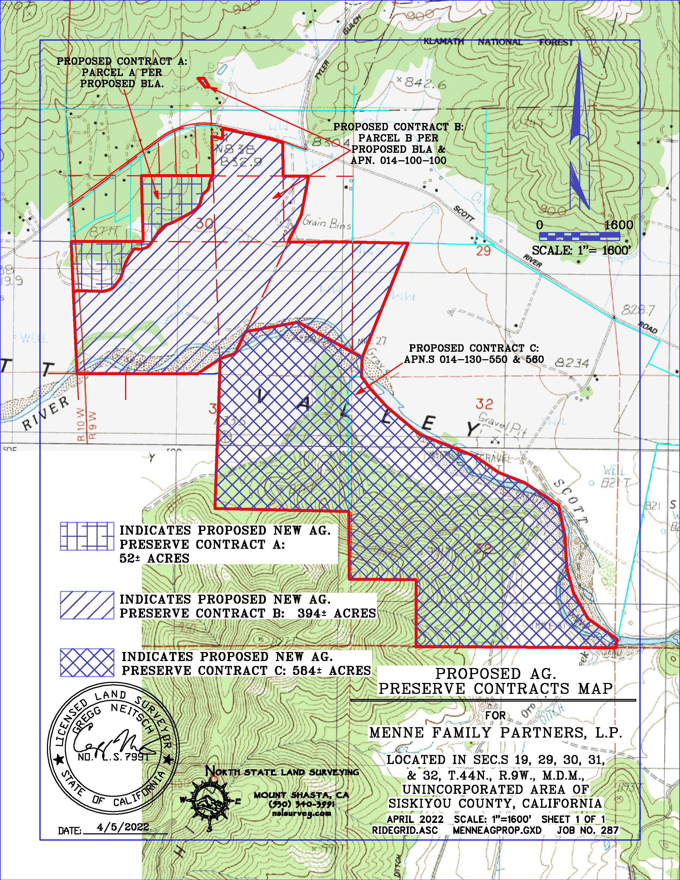
Figure 2: Proposed Williamson Act Contracts Exhibit Map

The Zone Change and Boundary Line Adjustment were initially considered by the Planning Commission at a public hearing on March 16, 2022. Following the hearing, the Planning Commission voted 4-0, with one commissioner absent, and adopted Resolution PC 2022-005, conditionally approving the associated Boundary Line Adjustment (BLA-21-31) and recommending that the Board of Supervisors adopt the CEQA Exemption for the project and approve the proposed rezone (Z-22-02).
Notice of the project was published and posted as required prior to the Board of Supervisors meeting and no public comments were received as of the preparation of this staff report.

Environmental Review
Staff evaluated the project’s potential for environmental impacts by reviewing the project relative to Appendix G of the CEQA Guidelines. Based on this review, it was determined that the rezone, as proposed, would not adversely impact the environment.
Because there is not substantial evidence, in light of the whole record before the County, that the proposed zone change and boundary line adjustment may have a significant effect on the environment, staff is recommending that the Board of Supervisors make the finding that the project is exempt from the California Environmental Quality Act (CEQA) pursuant to the “common sense exemption” of CEQA Guidelines Section 15061(b)(3), which states that “CEQA applies only to projects which have the potential for causing a significant effect on the environment. Where is can be seen with certainty that there is no possibility that the activity in question may have a significant effect on the environment, the activity is not subject to CEQA.”
Additionally, staff is recommending this project be determined exempt pursuant to the Class 1 exemption that is applicable to Existing Facilities (CEQA Guidelines Section 15301) and the Class 5 exemption that is applicable to Minor Alterations in Land Use Limitations (CEQA Guidelines Section 15305(a)). Class 1 consists of the operation, repair, maintenance, permitting, leasing, licensing, or minor alteration of existing public or private structures, facilities, mechanical equipment, or topographical features, involving negligible or no expansion of use beyond that existing at the time of the lead agency’s determination. Class 1 applies to the project because the project includes an existing facility, such as the existing agricultural operation and single-family dwelling that are on the project site. Class 5 consists of minor alterations in land use limitations in areas with an average slope of less than 20%, which do not result in any changes of land use or density, including minor lot line adjustments, such as the one proposed as part of this project. Class 5 applies to this project because a BLA is considered a minor lot line adjustment.
Also, staff recommends the proposed agricultural preserve and Williamson Act contract amendments be determined categorically exempt from the California Environmental Quality Act (CEQA) pursuant to CEQA Guidelines Section 15317, Open Space Contracts or Easements.
The proposed CEQA exemptions must be considered together with any comments received during the public review process. Further, the exemptions can only be approved if the finding is made, based on the whole record before it, that there is not substantial evidence that there are unusual circumstances (including future activities) which might reasonably result in the project having a significant effect on the environment.

Recommended Action
As detailed in Resolution PC 2022-005, it is the recommendation of the Planning Commission that the Board of Supervisors approve the proposed Zone Change. Should the Board of Supervisors concur with the recommendation of the Planning Commission, the Board of Supervisors must adopt an ordinance amending Zoning District Map 10-6.205-284.
Also, should the Board of Supervisors concur with staff’s analysis, staff recommends that the Board of Supervisors find that the proposed modifications to the agricultural preserves and Williamson Act contracts are exempt from CEQA and approve said modifications
A draft motion to this effect is provided below.

Recommended Motions
I move to take the following actions:
- Introduce, waive, and approve the first reading of the proposed Menne rezoning to amend Zoning District Map 10-6.205-284; and
- Direct the Clerk to schedule a continued public hearing on adoption of the CEQA exemption and a second reading of the ordinance amending Zoning District Map 10-6.205-284.
- Direct the Clerk to schedule a continued public hearing on adoption of the resolution amending the existing agricultural preserves, the resolution approving the rescission and reentry of the Williamson Act contracts and CEQA exemption.

Attachments
- Draft Ordinance No. _______, an Ordinance of the County of Siskiyou, State of California, Reclassifying Land in the Unincorporated Area West of Fort Jones from Prime Agricultural, 80-acre minimum parcel size (AG-1-B-80) to Rural Residential Agricultural, 10-acre minimum parcel size (R-R-B-10) on APN: 014-361-420 and 014-130-490; Township 44 North, Range 9 West, Sections 30, MDB&M
- Draft Resolution Amending the Existing Agricultural Preserves
- Draft Resolution Approving the Rescission of the Existing Contracts and Reentry into new Williamson Act Contracts
- Amended Williamson Act Contracts
- Z-22-02 and BLA-21-31 Planning Commission Staff Report – March 16, 2022
- Signed Resolution PC 2022-005

