McCloud and Cross-Connect Cost Estimate

# Cross-Connect



Based on July 1, 2021 – June 30, 2026 CENIC contract (excerpted above), the Cross-Connect for the Yreka branch **will be $1,800 per year** ($150 per month).

There are no taxes/fees/surcharges associated with the Cross-Connect charge. The figure cited in the contract is the total amount.

# McCloud Costs

## Service Costs



Based on July 1, 2021 – June 30, 2026 CENIC contract, McCloud’s cost before taxes will be $9,000 per year ($750 per month)

## Taxes/Fees/Surcharges

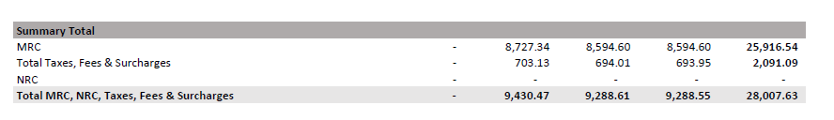

Based on the July/August/September 2021 invoice for the 11 other Siskiyou County branches served by CENIC, we can estimate that the average taxes/fees/surcharges for McCloud will be approximately 7.5%.

$$\frac{\$2,091.09}{\$28,007.63}=7.446\%$$

This would annualize to $675 per year ($56.25 per month).

## Total Costs for McCloud

The estimate cost for **McCloud’s first year of service would be $9,675**.