
Siskiyou County
Administrative Staff Report
December 1, 2020

Shasta Home Parcels Boundary Line Adjustment (BLA1937)
Applicant: Shasta Home Parcel LLC
Property Owners: Shasta Home Parcel LLC,
Shasta Farm Property West LLC
Shasta North Parcel B LLC
PO Box 58
Gazelle, CA 96034-0058
Representatives: Al Morris
Al Morris Land Surveying
PO Box 60
Gazelle, CA 96034
Project Summary: The applicant requests approval of a minor boundary line adjustment to reconfigure three existing legal parcels.
Owner | APN | Original Acreage | Adjustment | Final Acreage
Humanity for Horses | 022-221-190 (Por. of Parcel 1) | 4.49 | 0.00 | 4.49
Humanity for Horses | 022-221-240 (Por. of Parcel 1) | 17.98 | 0.00 | 17.98
Humanity for Horses | 022-250-020 (Por. of Parcel 1) | 162.80 | -117.11 | 45.69
Humanity for Horses | 022-250-640 (Por. of Parcel 1) | 30.79 | 0.00 | 30.79
Humanity for Horses | 022-250-650 (Por. of Parcel 1) | 186.98 | +23.20 | 210.18
Shasta Farm Property West LLC | 022-250-030 (Parcel 2) | 166.94 | -22.96 | 143.98
Shasta North Parcel B LLC | 022-250-360 (Parcel 3) | 163.21 | +116.87 | 280.08

Location: The project site is located north of Scarface Road, approximately 3 miles northwest of Gazelle on the APNs listed in the table below; T43N, R6W, S19, 29 & 30 MDB&M.
General Plan: Soils: Erosion Hazard; Building Foundation Limitations: Severe Pressure Limitations Soils; Soils: Severe Septic Tank Limitations; Critical Deer Wintering Area; Prime Agricultural Soils
Zoning District: Prime Agricultural (AG-1) and Non-Prime Agricultural (AG-2-B-40)
Current Use: Agricultural
Environmental: Because the project is a minor lot line adjustment involving properties with an average slope of less than 20 percent and will not result in a change in land use or density, it is categorically exempt from environmental review pursuant to CEQA Guidelines Section 15305, Minor Alterations in Land Use Limitations.

Project Review: December 27, 2020 Application Submitted
April 20, 2020 APA-20-01 Submitted
June 11, 2020 Start of Local Review
June 23, 2020 End of Local Review

Comments: Environmental Health – February 11, 2020
Environmental Health has reviewed this proposed BLA and has no objections to this project. Parcel A contains a single-family dwelling, septic system (PN 07-089) and well. Parcel C is also developed with a single-family dwelling, septic system (PN’s 01587 & 82-83) and groundwater well (PN W07-118). Parcel B is undeveloped agricultural land. The proposed BLA falls within the County’s sewage density standards and ample expansion area exists for both septic systems on Parcels A & C.

Recommendation: Staff recommends approval of the Shasta Home Parcels Boundary Line Adjustment (BLA1937) based on the findings contained in the staff report.

Planning Division Approval:
Based on the conditions and findings contained within this staff report, the Planning Division of the Siskiyou County Community Development Department approves the Shasta Home Parcels Boundary Line Adjustment (BLA1937).
Approved by:

County of Siskiyou

Community Development Department

Kirk Skierski, Deputy Director of Planning Date of Approval
Preparation: Prepared by the Siskiyou County Planning Division (R. Jereb) on June 23, 2020. Copies are available for review at Siskiyou County Planning, 806 S. Main Street, Yreka, California.

Analysis
Parcel Creation
Legal Parcel 1
APN 022-221-190 and 022-221-240 were legally created as Parcel 1 of Waiver W-87-78, which was filed for record in the Siskiyou County Recorder’s Office on September 27, 1978 (Volume 833, Page 620).
APN 022-250-020 was legally created by Patent and given Homestead Certificate Number 1439, which was filed for record in the Siskiyou County Recorder’s Office on August 4, 1893 (Book 13 of Patents, Page 67). It was later discussed as part of Certificate of Compliance (CC-08-06) as Parcel 5, which was filed for record in the Siskiyou County Recorder’s Office on August 13, 2008 (Document Number 08-0008967).
APN 022-250-640 was legally created by Patent Number 04-89-0077, which was filed for record in the Siskiyou County Recorder’s Office on September 22, 1989 (Document Number 89-0011491).
APN 022-250-650 was legally created by Grant Deed, which was filed for record in the Siskiyou County Recorder’s Office on October 28, 1969 (Volume 584, Page 332).
All of the above parcels were later modified by Boundary Line Adjustment (BLA-10-01) and together are Parcel “I”, which was filed for record in the Siskiyou County Recorder’s Office on May 21, 2010 (Document Number 10-0004328).
Legal Parcel 2
APN 022-250-030 was legally created by Patent and given Homestead Certificate Number 2068, which was filed for record on in the Siskiyou County Recorder’s Office on January 30, 1899 (Book 6 of Patents, Page 269). The parcel was never subsequently modified.

Legal Parcel 3
The north-half of APN 022-250-360 is a legal parcel created by Grant Deed, which was filed for record in the Siskiyou County Recorder’s Office on November 8, 1965 (Volume 522, Page 790). It was later discussed as part of Certificate of Compliance (CC-08-06) as Parcel 6, which was filed for record in the Siskiyou County Recorder’s Office on August 13, 2008 (Document Number 08-0008967). It was never subsequently modified.

Improvements
Proposed Parcel A is developed with a single-family dwelling, septic system, and groundwater well in addition to accessory structures to the single-family dwelling and agricultural uses on the property.
Proposed Parcel B is developed for agricultural uses.
Proposed Parcel C is developed with a single-family dwelling, septic system, and groundwater well in addition to agricultural uses on the property.

Zoning/ Resulting Parcels
Approval of the Shasta Home Parcel boundary line adjustment would transfer land between three existing legal parcels, resulting in one 309-acre parcel, one 280-acre parcel, and one 144-acre parcel. Subsequent to the boundary line adjustment, the resultant parcels would be consistent with all currently zoning requirements of Prime Agricultural (AG-1) and Non-Prime Agricultural, 40 acre minimum parcel size (AG-2-B-40) zoning districts.

Williamson Act Contracts
APN 022-250-650 is encumbered by an existing Williamson Act Contract that was recorded February 25, 1972 in Book 651, page 131, Siskiyou County Records. The contract is also identified as Assessor’s Contract No. 72004.
APN 022-250-020 and 022-250-360 are encumbered by an existing Williamson Act Contract that was recorded February 25, 1974 in Book 704, page 310, Siskiyou County Records. The contract is also identified as Assessor’s Contract No. 74002.
The County’s Rules for the Establishment and Administration of Agricultural Preserves and Williamson Act Contracts, adopted February 7, 2012, and California Government Code Section 51257 regulate Boundary (Lot) Line Adjustments (BLA) on contracted land. The County Board of Supervisors and property owners will need to mutually agree to rescind the existing contracts and simultaneously enter into new contracts. The new contracts would reflect the new parcel boundaries approved with the BLA. The BLA cannot be approved until the Board of Supervisors makes certain findings pursuant to Government Code Section 51257 and approves the new contracts. Findings pursuant to Government Code Section 51257 are detailed in the Findings section of this staff report. Should the Board make the findings and approve the new contracts, the BLA would be approved and the BLA and Williamson Act contracts would be recorded concurrently.
To this end, on December 1, 2020, the Siskiyou County Board of Supervisors made findings pursuant to Government Code Section 51257 and approved the new contracts.
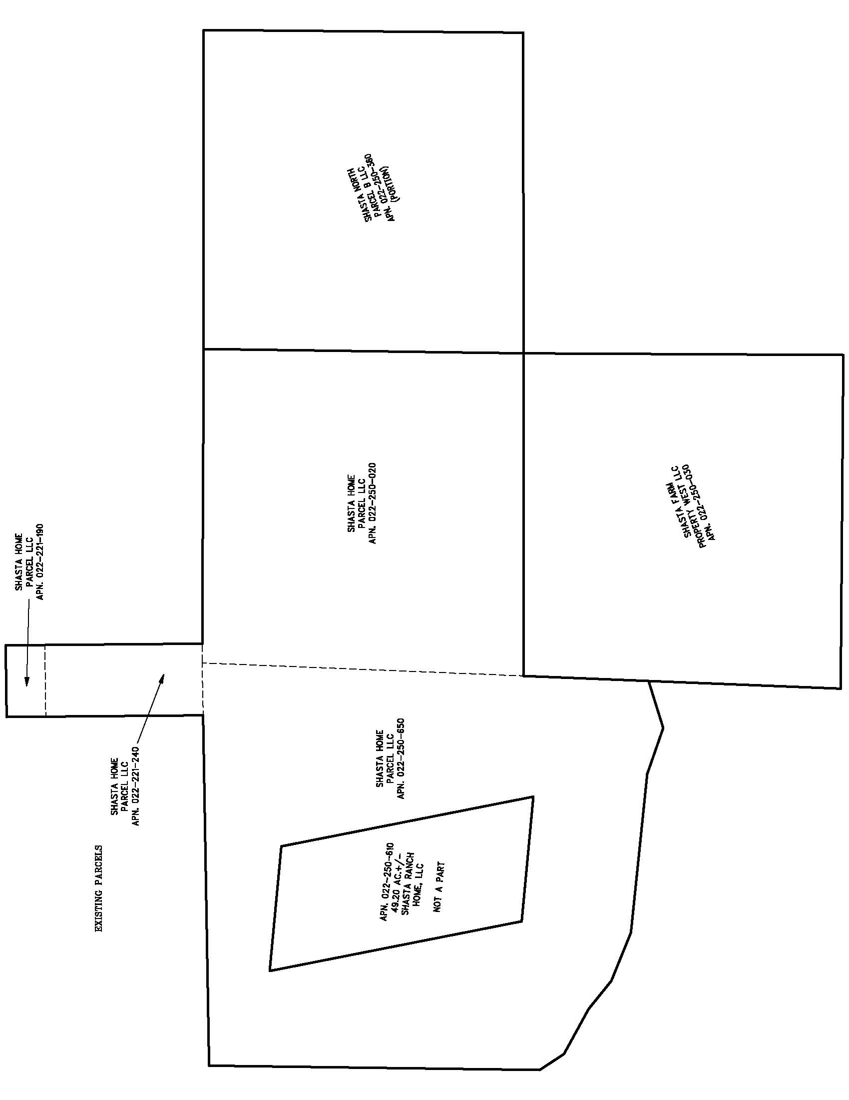
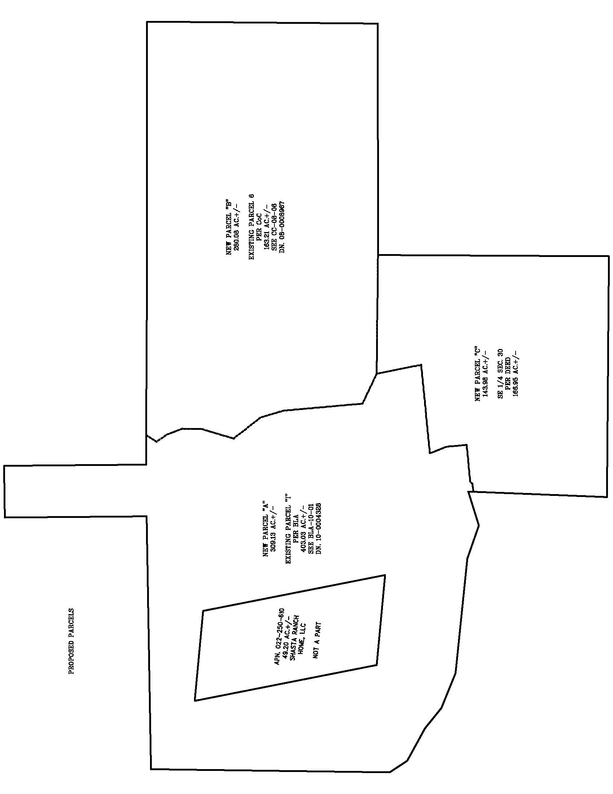

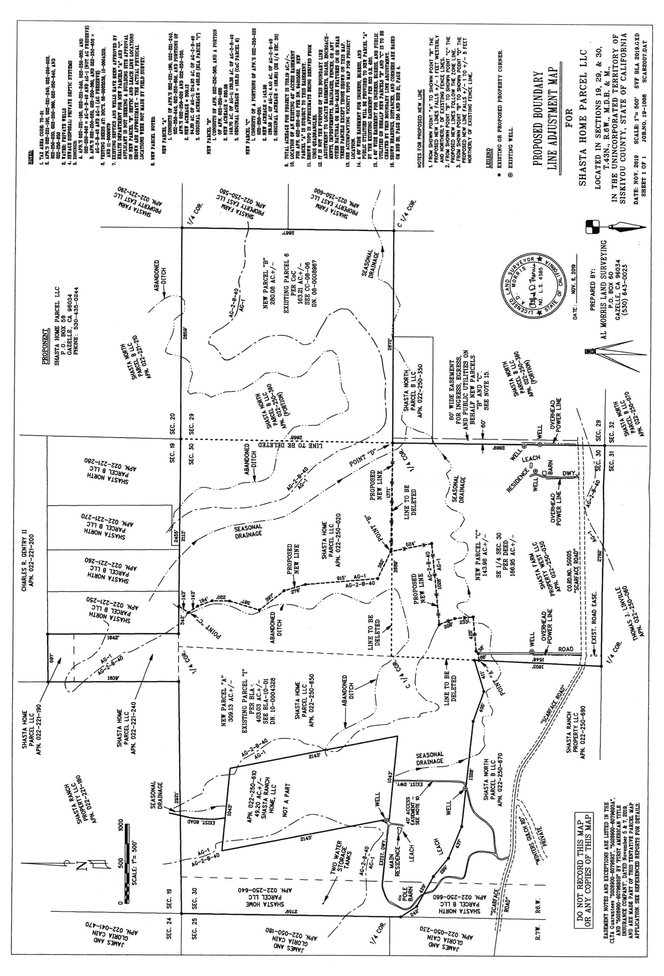

Findings

BLA Findings
- Because the proposed boundary line adjustment involves four or fewer existing adjoining parcels, where the land taken from one parcel would be added to an adjoining parcel, and because a greater number of parcels than originally existed would not be created, the proposed boundary line adjustment is exempt from the requirements of the Subdivision Map Act pursuant to Government Code Section 66412(d).
- Pursuant to Government Code Section 66412(d), the Planning Division of the Siskiyou County Community Development Department has limited its review and approval of the Shasta Home Parcel Boundary Line Adjustment (BLA1937) to a determination of whether or not the parcels resulting from the proposed boundary line adjustment will conform to the Siskiyou County General Plan, Zoning Ordinance, and California Building Code.
- The proposed project is consistent with zoning designations and the applicable policies of the Siskiyou County General Plan.
- Access to the parcels is via Scarface Road, a public road, and is consistent with the applicable access policies of the Siskiyou County General Plan.
- The resulting lots of record, as designed, will not result in a significant change in the existing environment that would in any way threaten the public health, safety, peace, morals, comfort, convenience, or general welfare.
- Approval of the proposed project, which is a minor lot line adjustment between properties with an average slope of less than 20 percent that will not result in a change in land use or density, presents no possible significant impacts to the environment and is, therefore, exempt from the requirements of the California Environmental Quality Act pursuant to CEQA Section 15305, Minor Alterations in Land Use Limitations.

Williamson Act Findings – Government Code Section 51257
- Upon contract approval the subject parcels will be restricted to agricultural uses pursuant to Williamson Act guidelines for not less than 10 years.
- No net decrease in the amount of restricted land will result from BLA1937.
- At least 90 percent of the land under the former contract or contracts remains under the new contract or contracts.
- After the lot line adjustment, the parcels of land subject to contract will be large enough to sustain their agricultural use as defined in Section 51222. Resultant parcels will be 309, 280, and 144 acres, which all exceed the 40-acre minimum required.
- The BLA associated with this project will not compromise the long-term agricultural productivity of the parcel or other agricultural lands subject to a contract or contracts.
- The BLA associated with this project is not likely to result in the removal of adjacent lands from agricultural use.
- The BLA associated with this contract would not result in a greater number of developable parcels than existed prior to the adjustment and this BLA is consistent with the Siskiyou County General Plan.

Recording Requirements and Appeal Period
- The applicant shall provide a legal description of the parcel that is to exist. The legal description must be typed on plain white paper with one-inch borders. The legal description must be prepared and submitted by either a Registered Civil Engineer that is licensed to practice land surveying (registered in California prior to 1982) or a Licensed Land Surveyor, and be accompanied by a map showing the parcel as depicted by the legal description. The legal description and exhibit map shall be made to the satisfaction of the Deputy Director of Planning, whereupon they shall be recorded along with the other required boundary line adjustment documents.
- The applicant shall provide the Planning Division with the name of the local title company that will complete all title documents and record the final approval. The title company shall coordinate with the County Clerk’s office to concurrently record the BLA documents and new Williamson Act contracts. Upon recordation, the Planning Division shall be provided with copies of all documents including a "dated down" title report reflecting completion of all requirements.
- A notation shall be included on the recorded boundary line adjustment stating as follows:
“This approved boundary line adjustment relates only to issues of compliance or non-compliance with the Subdivision Map Act and local ordinances enacted pursuant thereto. The parcels described herein may be sold, leased, or financed without further compliance with the Subdivision Map Act or any local ordinances enacted pursuant thereto. Development of the parcels may require issuance of a permit or permits, or other grant or grants of approval.”
- The boundary line adjustment shall become null and void if the boundary line adjustment documents and any required deed(s) have not been recorded within one (1) year of the date of approval. A twelve (12) month extension of the expiration date may be obtained upon the submittal of a written application and fee to the Planning Division, prior to the expiration of the approved boundary line adjustment.
- The approval of the boundary line adjustment does not guarantee that said parcels: (1) can be built upon; (2) have legal access; (3) have water and sewer to support development; or (4) there is the ability to obtain the necessary permits or other grant or grants of approval to allow development.
- Within ten (10) days following the date of the decision of the Director, the decision for the Boundary Line Adjustment may be appealed to the Siskiyou County Planning Commission. The appeal shall be filed with the Clerk of the Board of the Planning Commission. If no appeal is filed, the approval will be deemed effective on December XX, 2020. If the applicant concurs with the approval, the applicant may submit the necessary information for completing the boundary line adjustment in accordance with the requirements, prior to the end of the appeal date.

APN 022-250-360 contains a full legal parcel as described in the Legal Description for PARCEL 6, and a portion of a second legal parcel. APN 022-250-350 and the portion of APN 022-250-360 that is in the Southwest ¼ of Section 29, Township 43 North, Range 6 West are together a legal parcel as described in the Legal Description for PARCEL 7. Both Legal Descriptions were recorded in Siskiyou County Official Records (Document Number 08-0008967) as part of a Certificate of Compliance (CC-08-06).

