Staff Report
Meeting Date: December 1, 2020
To: Siskiyou County Board of Supervisors
From: Rachel Jereb, Planner
Subject: Proposed Shasta North Parcel B LLC, Shasta Farm Property LLC, and Humanity for Horses Agricultural Preserve Amendment and Williamson Act Contract Rescission and Reentry (APA-20-01) and CEQA Determination
Exhibits: A. BLA-19-37 – Draft Administrative Staff Report
B. Draft Resolution Amending the Existing Agricultural Preserves
C. Draft Resolution Approving the Rescission and of the Existing Contracts and Reentry into New Contracts
D. Amended Williamson Act Contracts

Background and Discussion
On December 27, 2019, the County received an application for a boundary line adjustment (BLA-19-37) proposing the transfer of approximately 140 acres between three parcels currently owned by Shasta North Parcel B LLC, Humanity For Horses, and Shasta Farm Property West LLC. This relatively straightforward boundary line adjustment is complicated by the fact that two of the three parcels (the two owned by Humanity For Horses and Shasta North Parcel B LLC) are located in different agricultural preserves and are under separate Williamson Act contracts. Therefore, in order for the boundary line adjustment to be administratively approved and recorded, the Board would need to first approve the proposed Agricultural Preserve Amendment and Williamson Act Contract Rescission and Reentry (APA-20-01).
It is important to note that the project does not propose to remove or add property to the existing agricultural preserves. It would simply modify the boundaries of existing agricultural preserves and revise contracts to reflect the transfer of property from one owner to another.
Parcel History
Parcels contained within Contract No. 72004
On February 16, 1972, five parcels (APNs 022-250-070, 022-250-080, 022-220-190, 022-250-020, and 022-250-300 owned by Edwin and Wilma Buscombe) totaling approximately 1569 acres were approved to be an agricultural preserve under Williamson Act Contract No. 72004, as recorded in the Siskiyou County Records in Book 651 at Page 131. All five parcels were the subject of Certificate of Compliance (CC-08-06) as recorded in Siskiyou County Official Records as Document No. 08-0008967 on August 13, 2008. APN 022-250-020 was modified by Boundary Line Adjustment (BLA-10-01) as recorded in the Siskiyou County Official Records as Document Number 10-0004328 on May 21, 2010. Currently, all parcels are owned by Shasta North Parcel B, LLC, with the exception of APN 022-250-020, which is owned by Humanity for Horses.
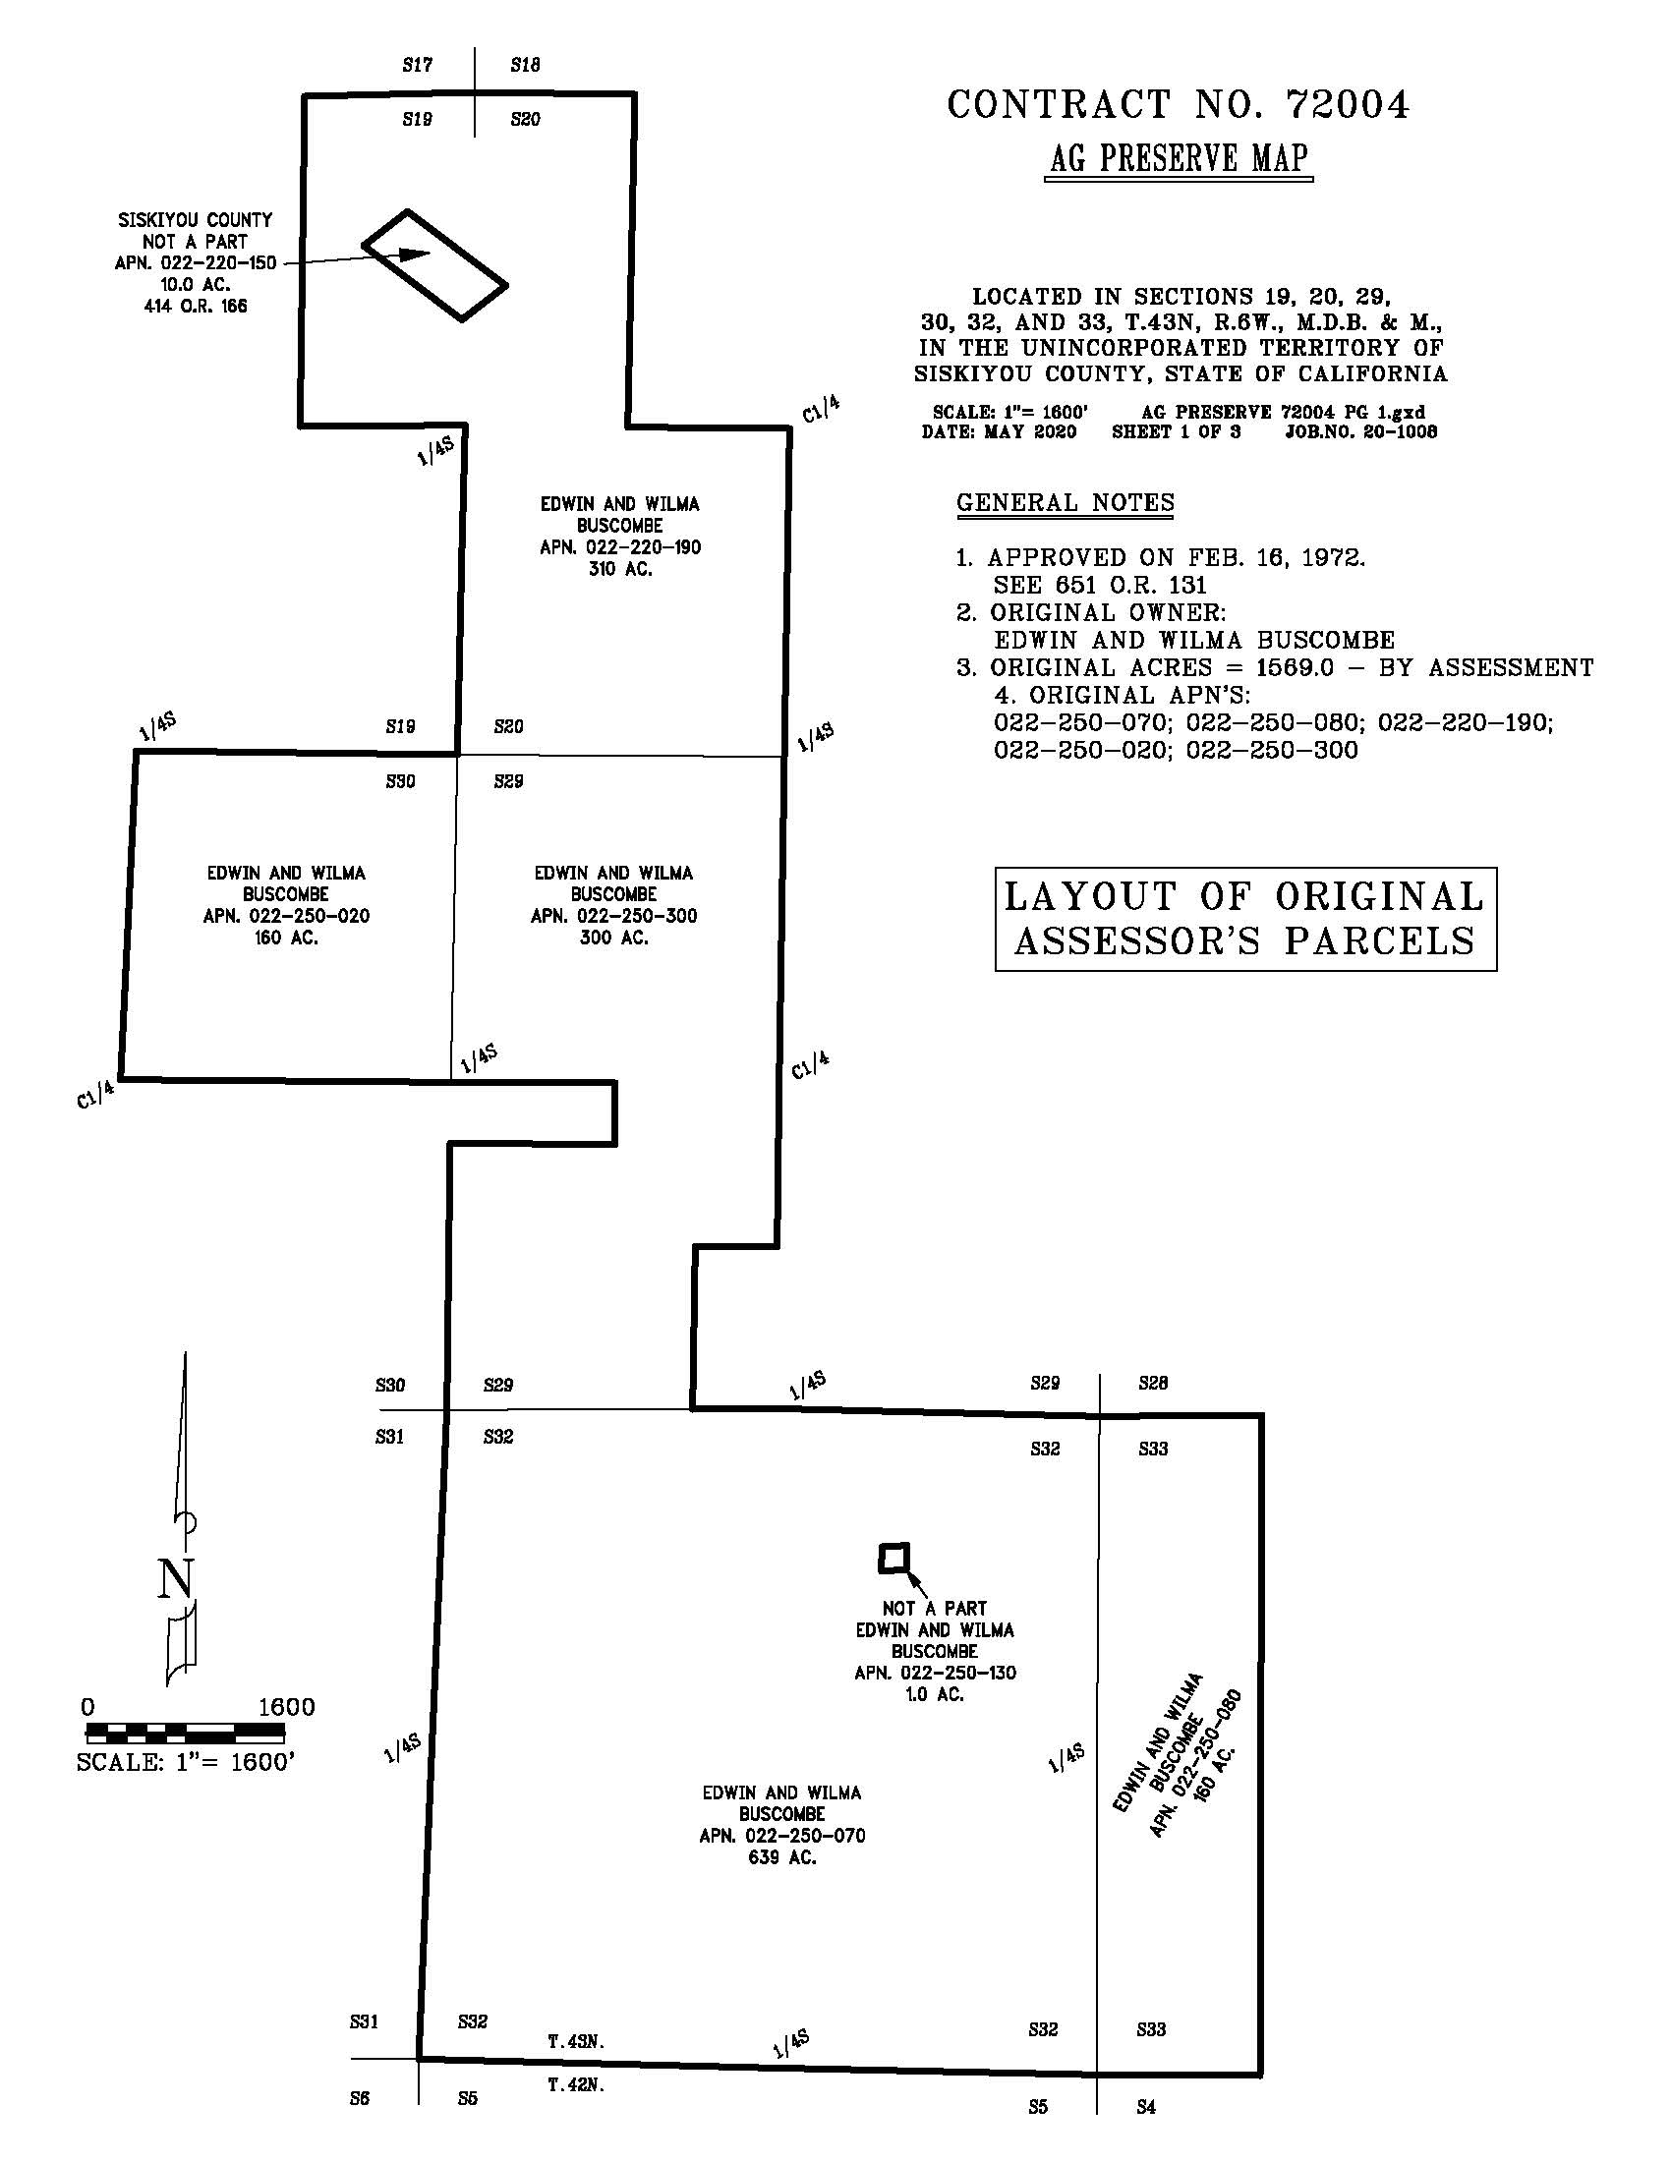
Figure 1: Original Parcel Configuration for Contract No. 72004
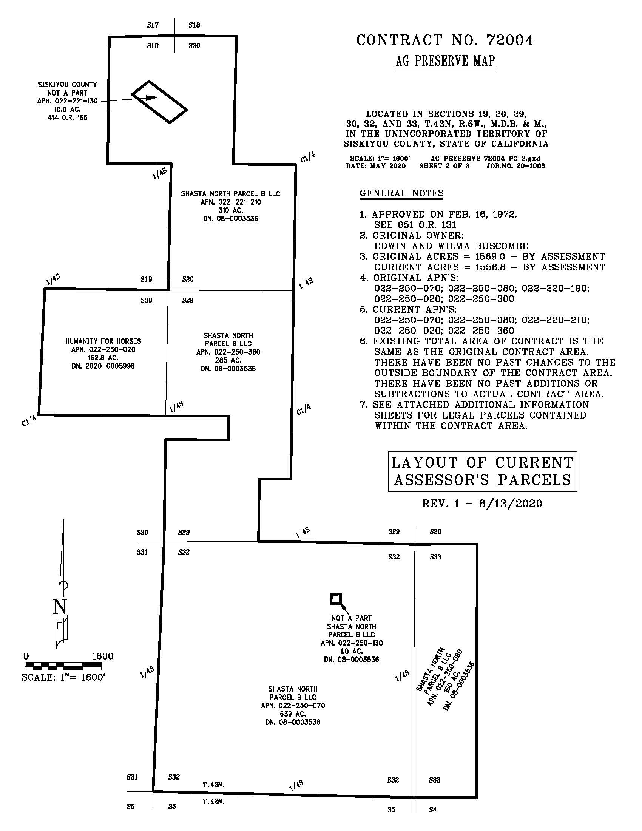
Figure 2: Current Parcel Configuration for Contract No. 72004
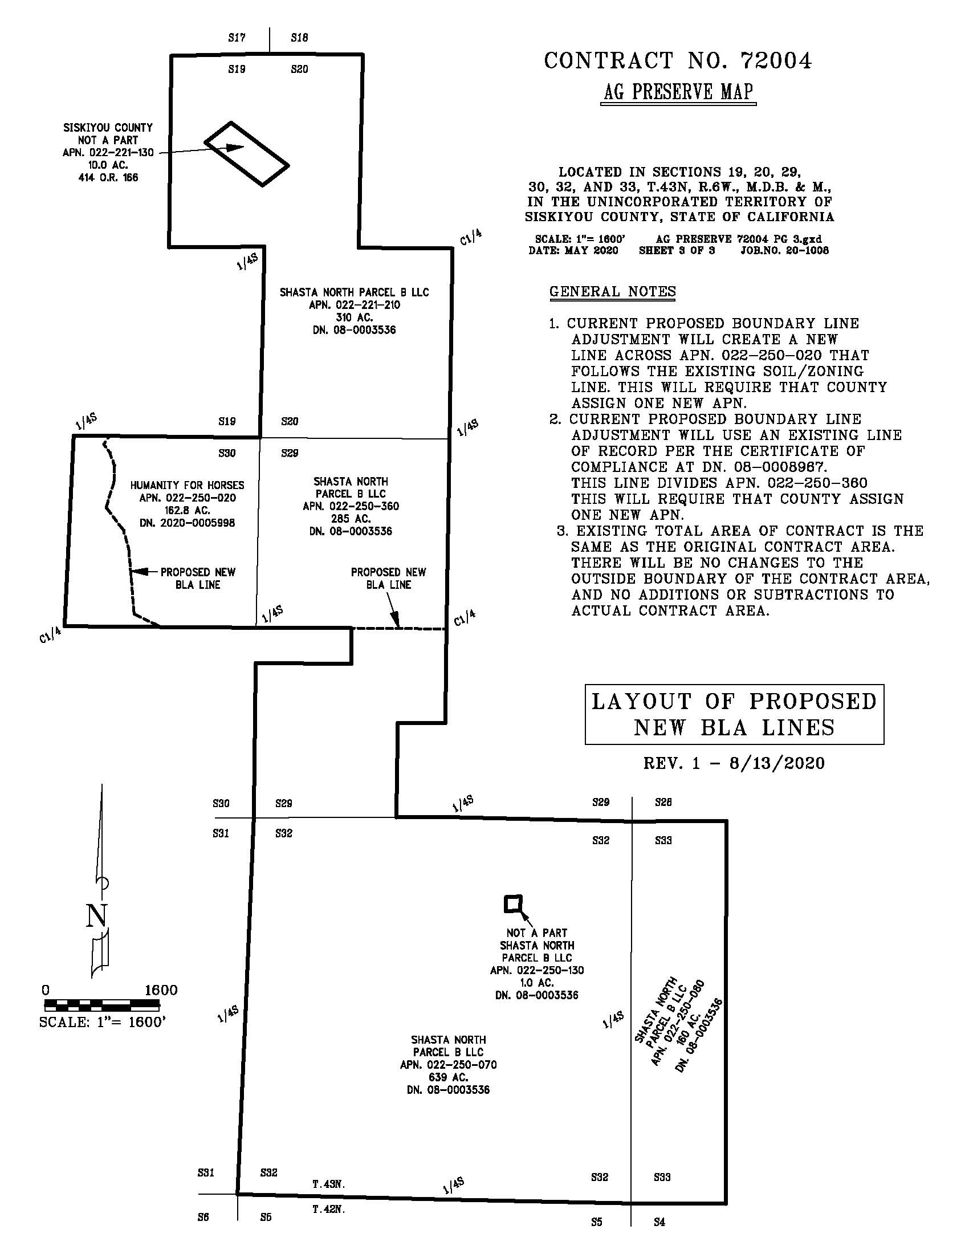
Figure 3: Post-BLA Parcel Configuration for Contract No. 72004
Parcels contained within Contract No. 74002
On February 20, 1974, two 320-acre parcels (APN 022-220-170 and 022-250-010, both owned by Virginia Small) were approved to be an agricultural preserve under Williamson Act Contract No. 74002, as recorded in the Siskiyou County Records in Book 704 at Page 309. APN 022-220-170 was remapped as APN 022-221-180, but otherwise remains the same. APN 022-250-010 was modified by Boundary Line Adjustment (BLA-92-30) as recorded in Siskiyou County Official Records as Document Number 94-015582 on October 28, 1994. A second BLA (BLA-10-01) that modified the boundaries was recorded in the Siskiyou County Official Records as Document Number 10-0004328 on May 21, 2010. BLA-10-01 noted that if the BLA was approved, “both the Ag Preserve contracts will need to be rescinded and re-issued to reflect the changed parcel boundaries.” The contract was not rescinded or reissued subsequent to the BLA being recorded. As a result of the two BLAs, the original APN of 022-250-010 was separated into four APNs (022-250-610, 022-250-650, 022-250-670, and 022-250-690). These parcels are currently owned by Humanity for Horses, with the exception of APN 022-250-690, which is owned by Shasta Farm Property LLC.

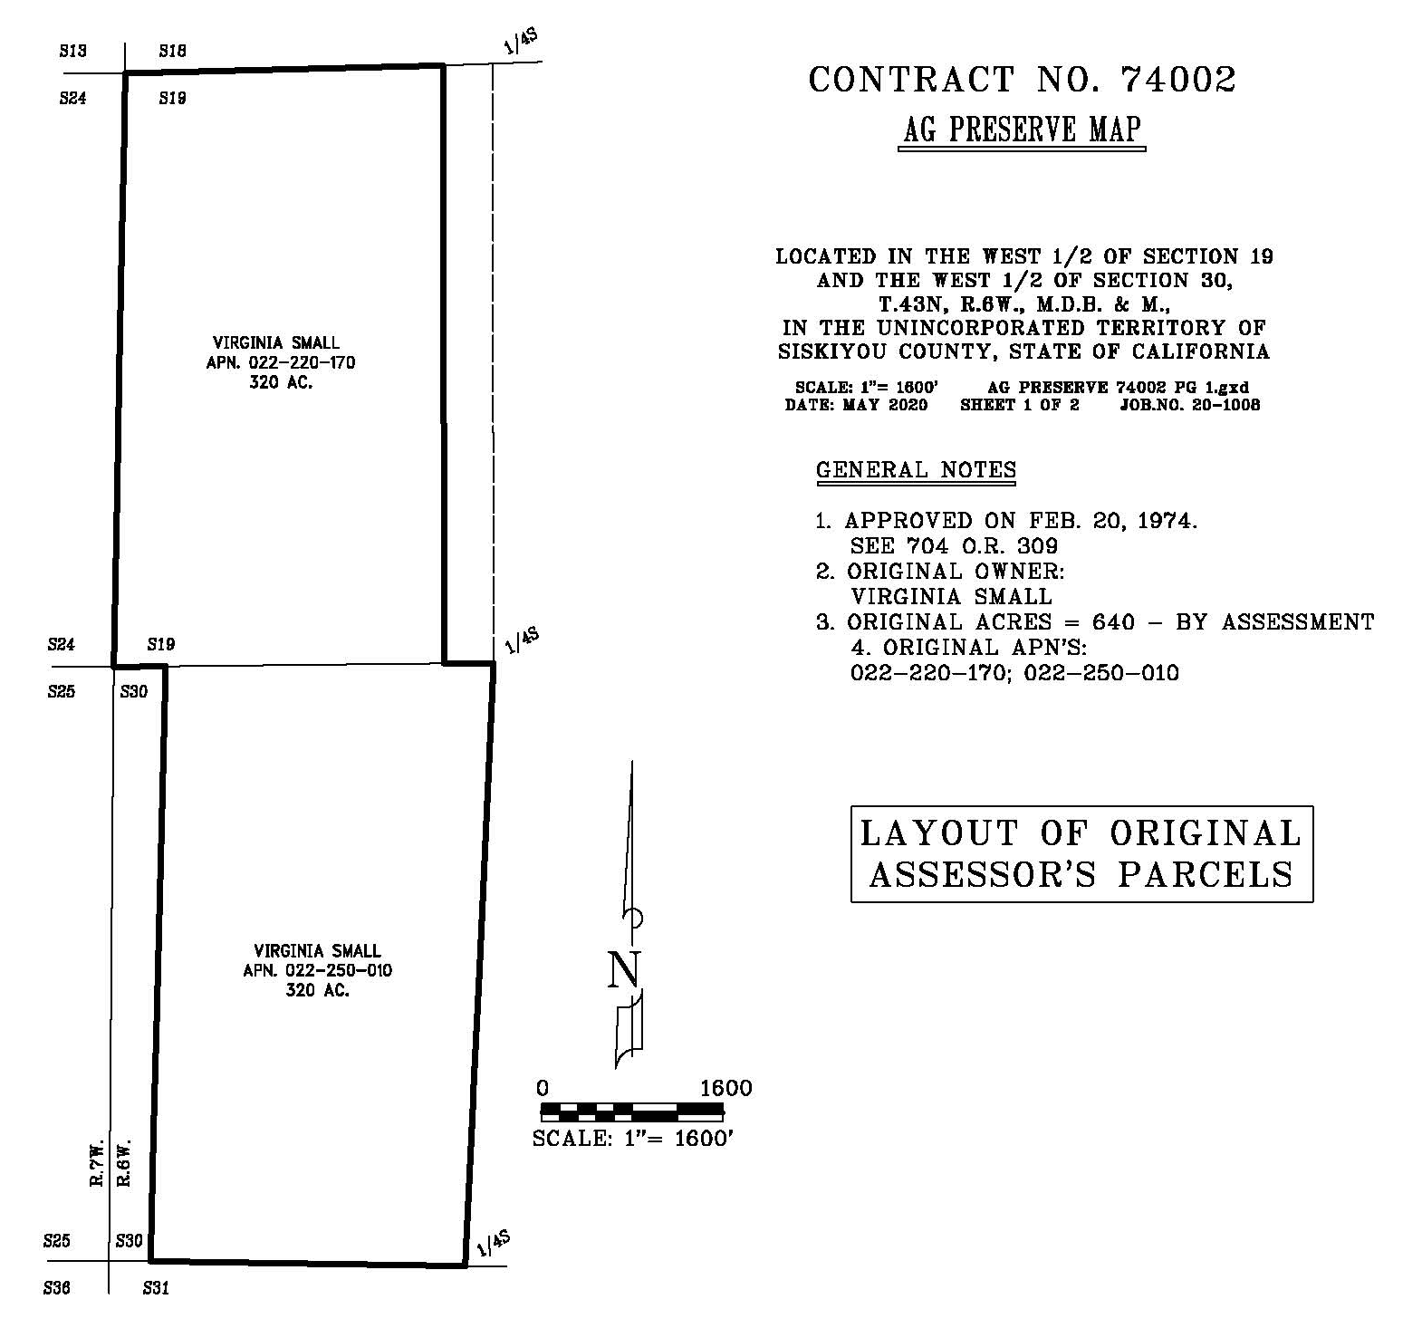Figure 4: Original Parcel Configuration for Contract No. 74002

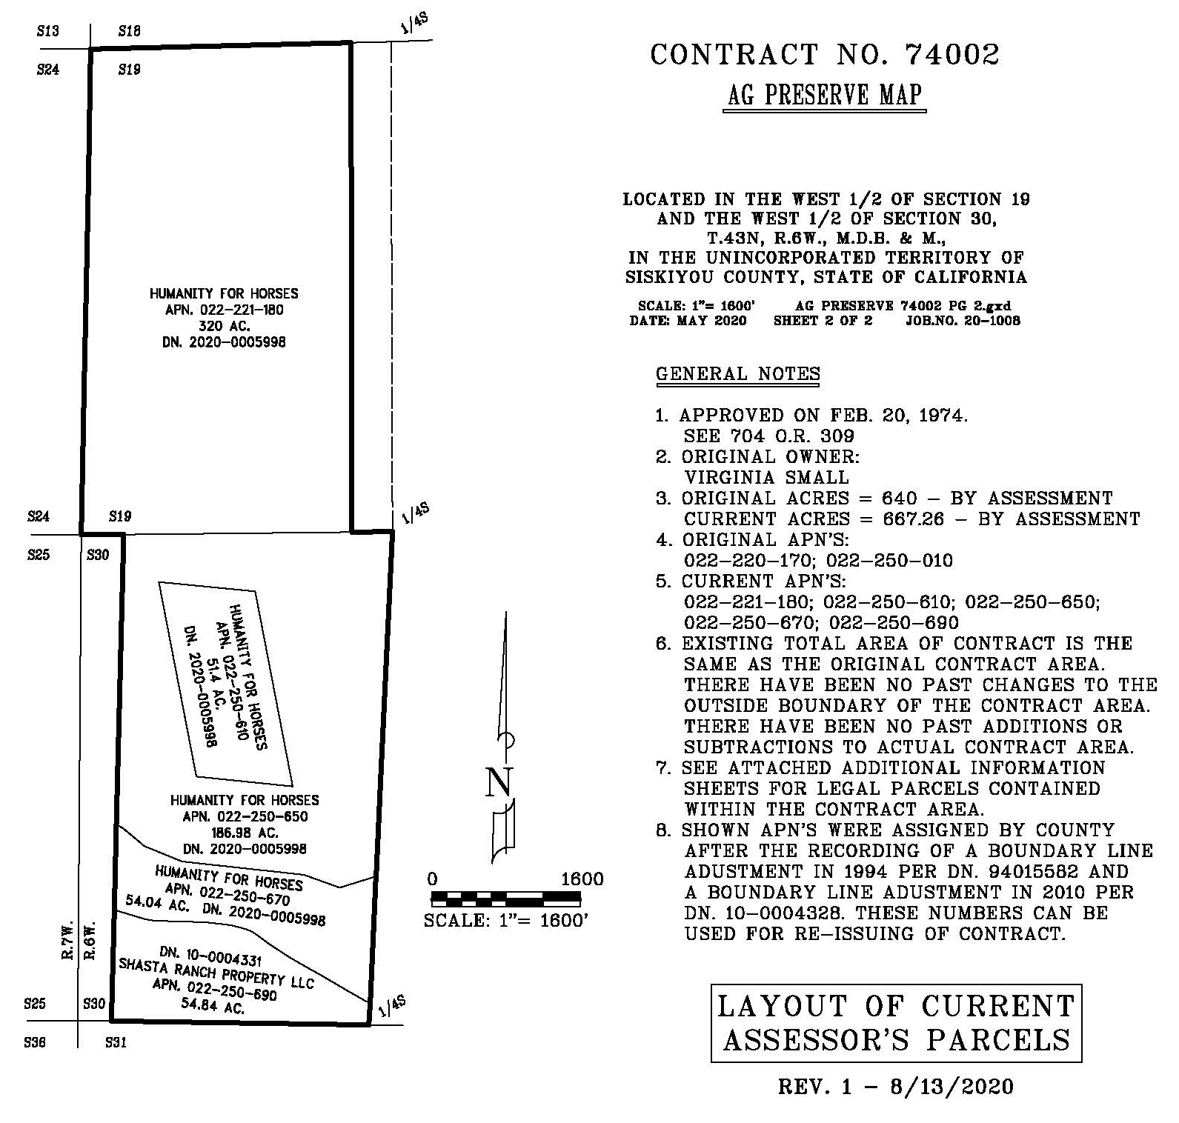Figure 5: Current Parcel Configuration for Contract No. 74002

Agricultural Preserve Amendments
The subject parcels are located in two different agricultural preserves. Humanity for Horses owns approximately 561 acres and Shasta Farm Property LLC (renamed from Shasta Ranch Property LLC on February 5, 2008) owns approximately 54.84 acres of agricultural property that was placed in an agricultural preserve through Board Resolution No. 404, Book 2 on January 28, 1969 (Contract No. 72004).
Humanity for Horses owns approximately 162.8 acres and Shasta North Parcel B LLC owns approximately 1394 acres of agricultural property that was placed in an agricultural preserve through Board Resolutions No. 356, Book 5 on January 30, 1974 (Contract No. 74002). Figure 5 of this staff report shows the resultant agricultural preserve boundaries should the Board approve the proposed agricultural preserve amendment and Williamson Act rescission and re-entry (APA-20-01) and upon administrative approval and simultaneous recordation of the proposed boundary line adjustment (BLA-19-37). Subsequent to the approval and recordation of the proposed projects, all Humanity for Horses will own all property under one particular agricultural preserve, and Shasta North Parcel B LL and Shasta Farm Property LLC (both companies are under common ownership) will own all property under a second agricultural preserve.
Attachment A to this Staff Report is the Administrative Staff Report (draft) prepared for the proposed boundary line adjustment (BLA-19-37). Attachment B is the draft resolution prepared for Board consideration that would, upon adoption, amend the applicable agricultural preserves.
Williamson Act Contract Rescission and Re-Entry
The 117.11 acres that would be transferred from Humanity for Horses to Shasta North Parcel B LLC are in a Williamson Act contract (Contract No. 72004) that includes a total of approximately 1556.8 acres. The 54.84 acres owned by Shasta Ranch Property LLC is in a Williamson Act Contract (Contract No. 74002). All the property that is subject to these proposed contract amendments are currently under Williamson Act contracts. The proposed amendments would simply modify the boundaries of the existing Agricultural Preserves and transfer ownership of 117.11 acres of this land from one property owner to the other. Upon approval of the resolutions and contract amendments now before the Board, and upon approval and recordation of the pending BLA, each property owner (Shasta North Parcel B LL and Shasta Farm Property LLC being separate companies held under common ownership) would have a single, unique Williamson Act contract covering their respective land holdings.
Attachment C is the draft resolution that, if adopted by the Board, approves the rescission of the Buscombe and Small Williamson Act contracts (Contract Nos. 72004 and 74002) and re-entry of the land into new Williamson Act contracts with the current owners under the proposed parcel configuration and authorizes the Board Chair to sign the new Williamson Act contracts (Attachment D).
Government Code Section 51230 and the County’s Williamson Act Guidelines require that agricultural preserves be a minimum of 100 acres. The proposed new agricultural preserves would comply with both State and County agricultural preserve requirements. Additionally, the proposed new Williamson Act contracts comply with the minimum parcel size requirements pursuant to Government Code Section 51222 and the County’s Williamson Act Guidelines. Pursuant to Government Code Section 51233, the Siskiyou County Local Area Formation Commission (LAFCo) was notified of the proposed changes to the agricultural preserves. Additionally, all property owners within 300’ of the project site were notified regarding the proposed changes to the agricultural preserves. No incorporated cities are located within the one-mile radius of the project site.
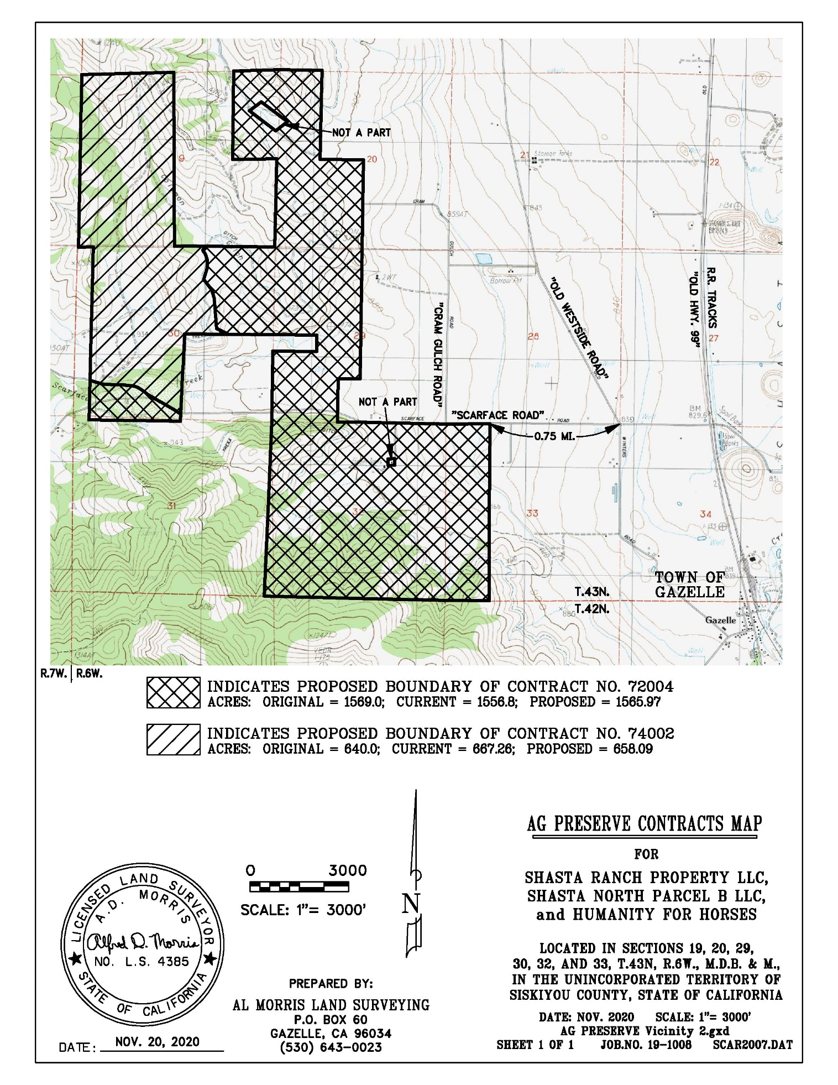Figure 6: Resultant Agricultural Preserve Boundaries

Environmental Review
Staff is proposing that the proposed project be considered categorically exempt from the California Environmental Quality Act (CEQA) pursuant to CEQA Guidelines Section 15317, Open Space Easements or Contracts. A Categorical Exemption implies that the project will not result in any significant adverse environmental effects. CEQA Guidelines Section 15317 specifically exempts the establishment of agricultural preserves and the making and renewing of open space contracts under the Williamson Act.
The Board of Supervisors must consider the proposed CEQA exemption together with any comments received during the public review process. Further, the exemption can only be approved if the Board finds, based on the whole record before it, that there is not substantial evidence that the project will have a significant effect on the environment. Accordingly, a finding to this effect has been incorporated into both draft resolutions prepared for the Board’s consideration.

Comments
Notice of the project was published and posted as required prior to the Board of Supervisors meeting and no public comment was received as of the preparation of this staff report.

Recommended Action
Should the Board of Supervisors concur with staff’s analysis, staff recommends that the Board of Supervisors find that the proposed modifications to the agricultural preserves and Williamson Act contracts are exempt from CEQA and approve said modifications by making the motion detailed below.

Recommended Motions
I move to take the following actions:
- Determine the project exempt from the California Environmental Quality Act (CEQA) pursuant to CEQA Guidelines Section 15317, Open Space Easements or Contracts; and
- Adopt the attached resolution amending the existing agricultural preserves; and
- Adopt the attached resolution approving the rescission and reentry of the applicable Williamson Act contracts.

