
SISKIYOU COUNTY LIBRARY

719 Fourth Street

Yreka, California 96097
(530) 842-8805 FAX: (530) 842-7001

MICHAEL PERRY, COUNTY LIBRARIAN

mperry@co.siskiyou.ca.us

March 16, 2020

Re: Additional expenses and reimbursement for Califa Broadband contract in FY 19/20

Summary
In our current Library Broadband contract, Cal-Ore planned to charge $1,250 per month per branch to 9 of our library branches. However, for the past three fiscal years (FY 16/17, FY 17/18 and FY 18/19), Cal-Ore has only charged $1,000 per branch per month (see Figure 1 for a past invoice, highlighting the charge to one of our branches, Dorris).

Starting in FY 19/20, Cal-Ore began to include the taxes and surcharges in our costs, increasing the previous average cost from $1,000 to $1,073 per branch per month (see Figure 2 for the most recent invoice of the charge at the same branch, Dorris). Note that this is still below the contracted price of $1,250 per branch per month.

To help offset the increase, Cal-Ore is also crediting the library with an estimate of the California Teleconnect Fund (CTF) credits we would receive and applying them in the current year (instead of processing them in the normal time frame which is usually 14 months after the end of the current fiscal year). The credit is $140 per branch per month.

We are also anticipating an additional $645 in additional surcharges and fees with our AT&T services for 2 of our branches, as they increased taxes and surcharges starting in November 2019.

Calculation
Cal-Ore increased expenses
The expenses for Cal-Ore service will increase by

$$9 branches x \$73.04 per month x 12 months≈\$7,888 for FY 19/20$$

AT&T increased expenses
AT&T’s monthly surcharges increased for 2 branches:

- Yreka $59.31 $84.65 per circuit (see Figures 3 and Figures 4)
- Montague $35.17 $50.20 per circuit (see Figures 5 and Figures 6)

We are budgeting these new monthly charges through the end of the fiscal.

For Yreka
$$2 circuits x \$25.34 per month x 8 months ≈\$405$$

For Montague
$$2 circuits x \$15.03 per month x 8 months ≈\$240$$

We anticipate an additional cost for AT&T service to be $\$405+\$240≈\$645.$

Overall Increased expenses (estimate)

$$\$7,888+\$645≈\$8,533$$

To safeguard against slight variations for the rest of the year, we will assume the overall expense will increase by $9,000 for the rest of the fiscal year.

Cal-Ore increased credits
We expect E-rate credits, assigned to our 712200 E-rate accounting line item in the amount of

$$9 branches x 140 per month x 9 months=\$11,340 for FY 19/20$$

We are only considering 9 months (July 2019 – March 2020) because the invoice including the E-rate credits for Apr – June 2020 will arrive after the close of the FY 19/20 accrual period and will be applied to the next fiscal year (FY 20/21).
Adjusting for increased expenses
We won’t have to revise the contract itself as the current encumbrance can absorb these increased expenses (as one of our library branches included in the contract is not yet receiving services).

However, we will have to adjust the current allocation share between the General Fund and Boles Fund (Activity 174). The Boles Fund is absorbing the “deadweight” of the current contract. All anticipated expenses are assigned to the General Fund.

 | General Fund | Boles Fund (Actv 174) | Contract Value
Current Share | $133,827 | $48,513 | $182,340
Proposed Share | $142,827 | $39,513 | $182,340

Budget Transfer Allocation
The budget transfer re-allocates the unexpected additional E-rate credits and re-distributes it to multiple line items, to offset other unanticipated library expenses.

Expense | Amount | Notes
723000 | $9,000 | Anticipated increase expenses for Broadband services
718000 | $2,100 | Unanticipated increased costs of tree removal
730000 | $240 | Unanticipated increased energy expenses
Total | $11,340

Figure 1 - Monthly cost for Cal-Ore service for FY 16/17, FY 17/18 and FY 18/19
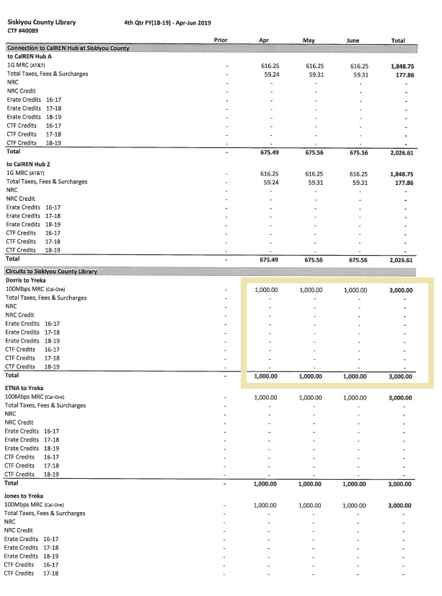

Figure 2- Monthly cost for Cal-Ore service beginning in FY 19/20
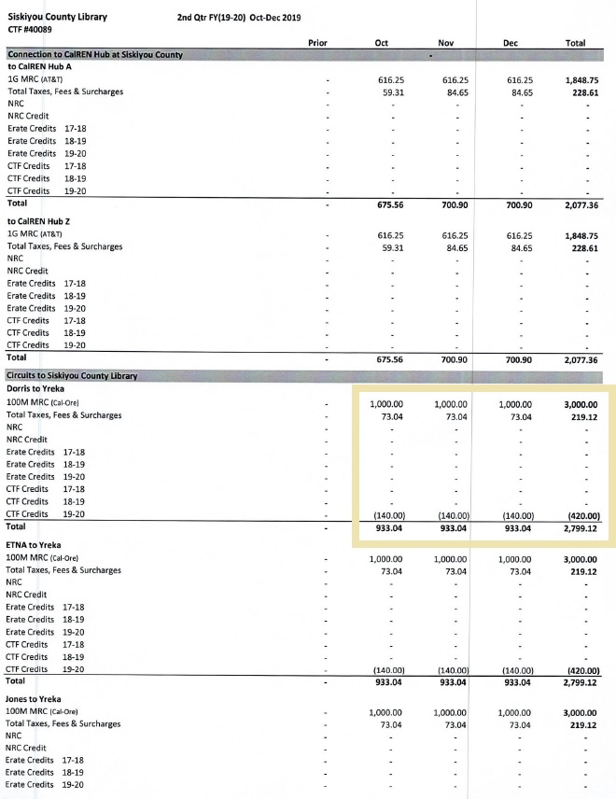

Figure 3 - Baseline AT&T costs for Yreka for Jul/Aug/Sep 2019
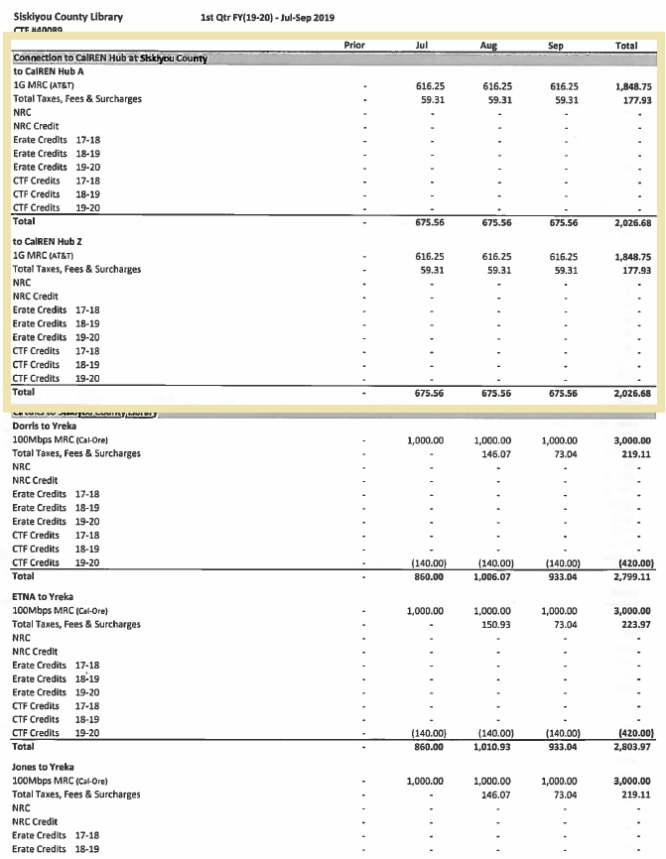

Figure 4 - New surcharges for AT&T for Yreka beginning Nov 2019
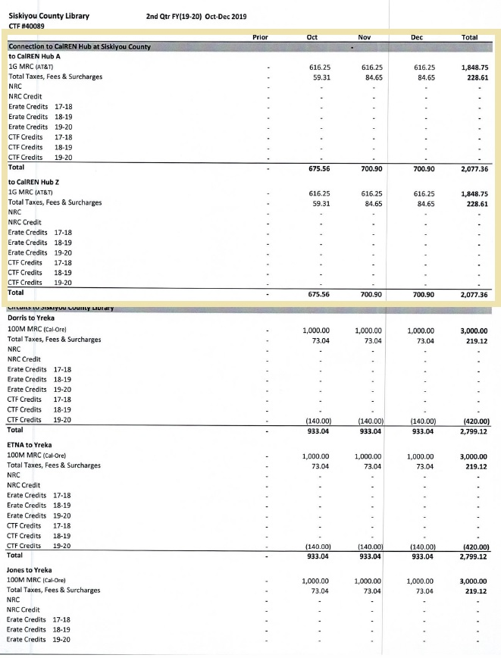

Figure 5 - Baseline AT&T costs for Montague for Jul/Aug/Sep 2019
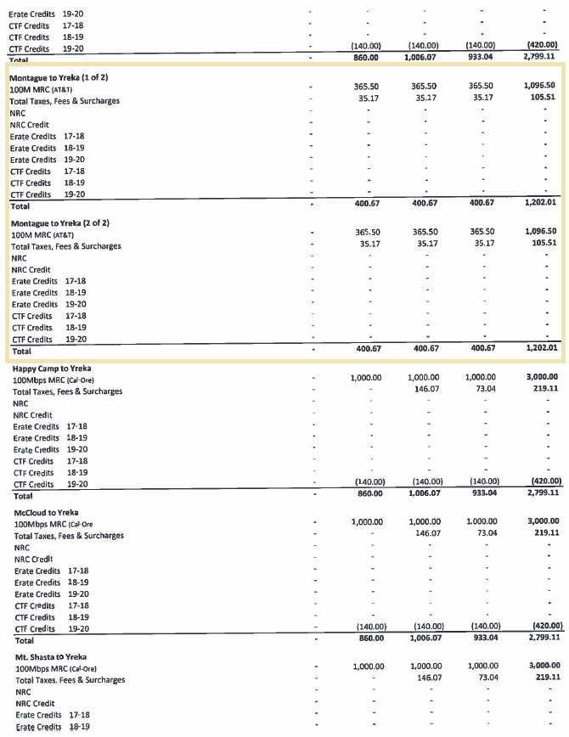

Figure 6 - New surcharges for AT&T for Montague beginning Nov 2019
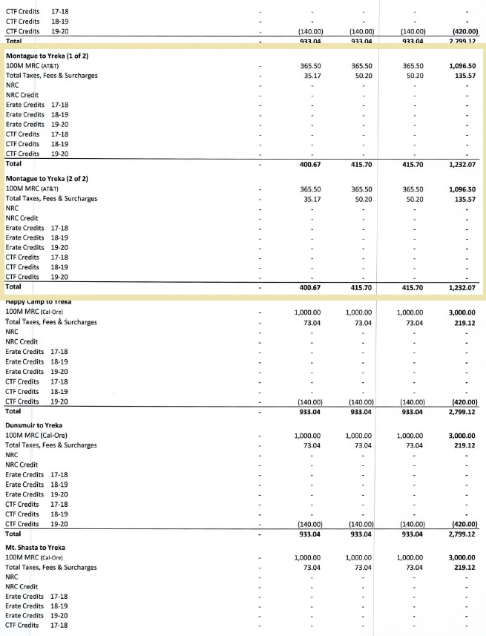

California Teleconnect Fund is the state equivalent of the Federal E-rate credits. For the purposes of accounting, we capture both E-rate and CTF credits under the E-rate credit accounting line, 712200.

