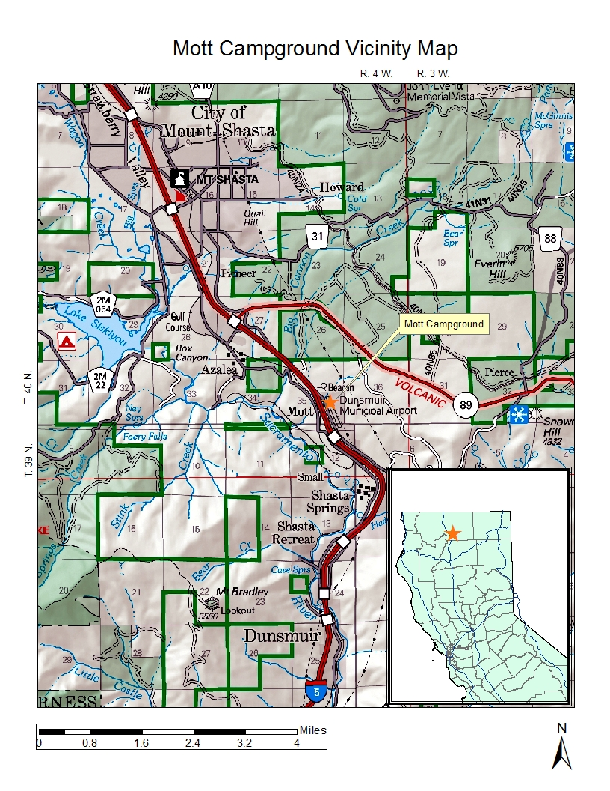
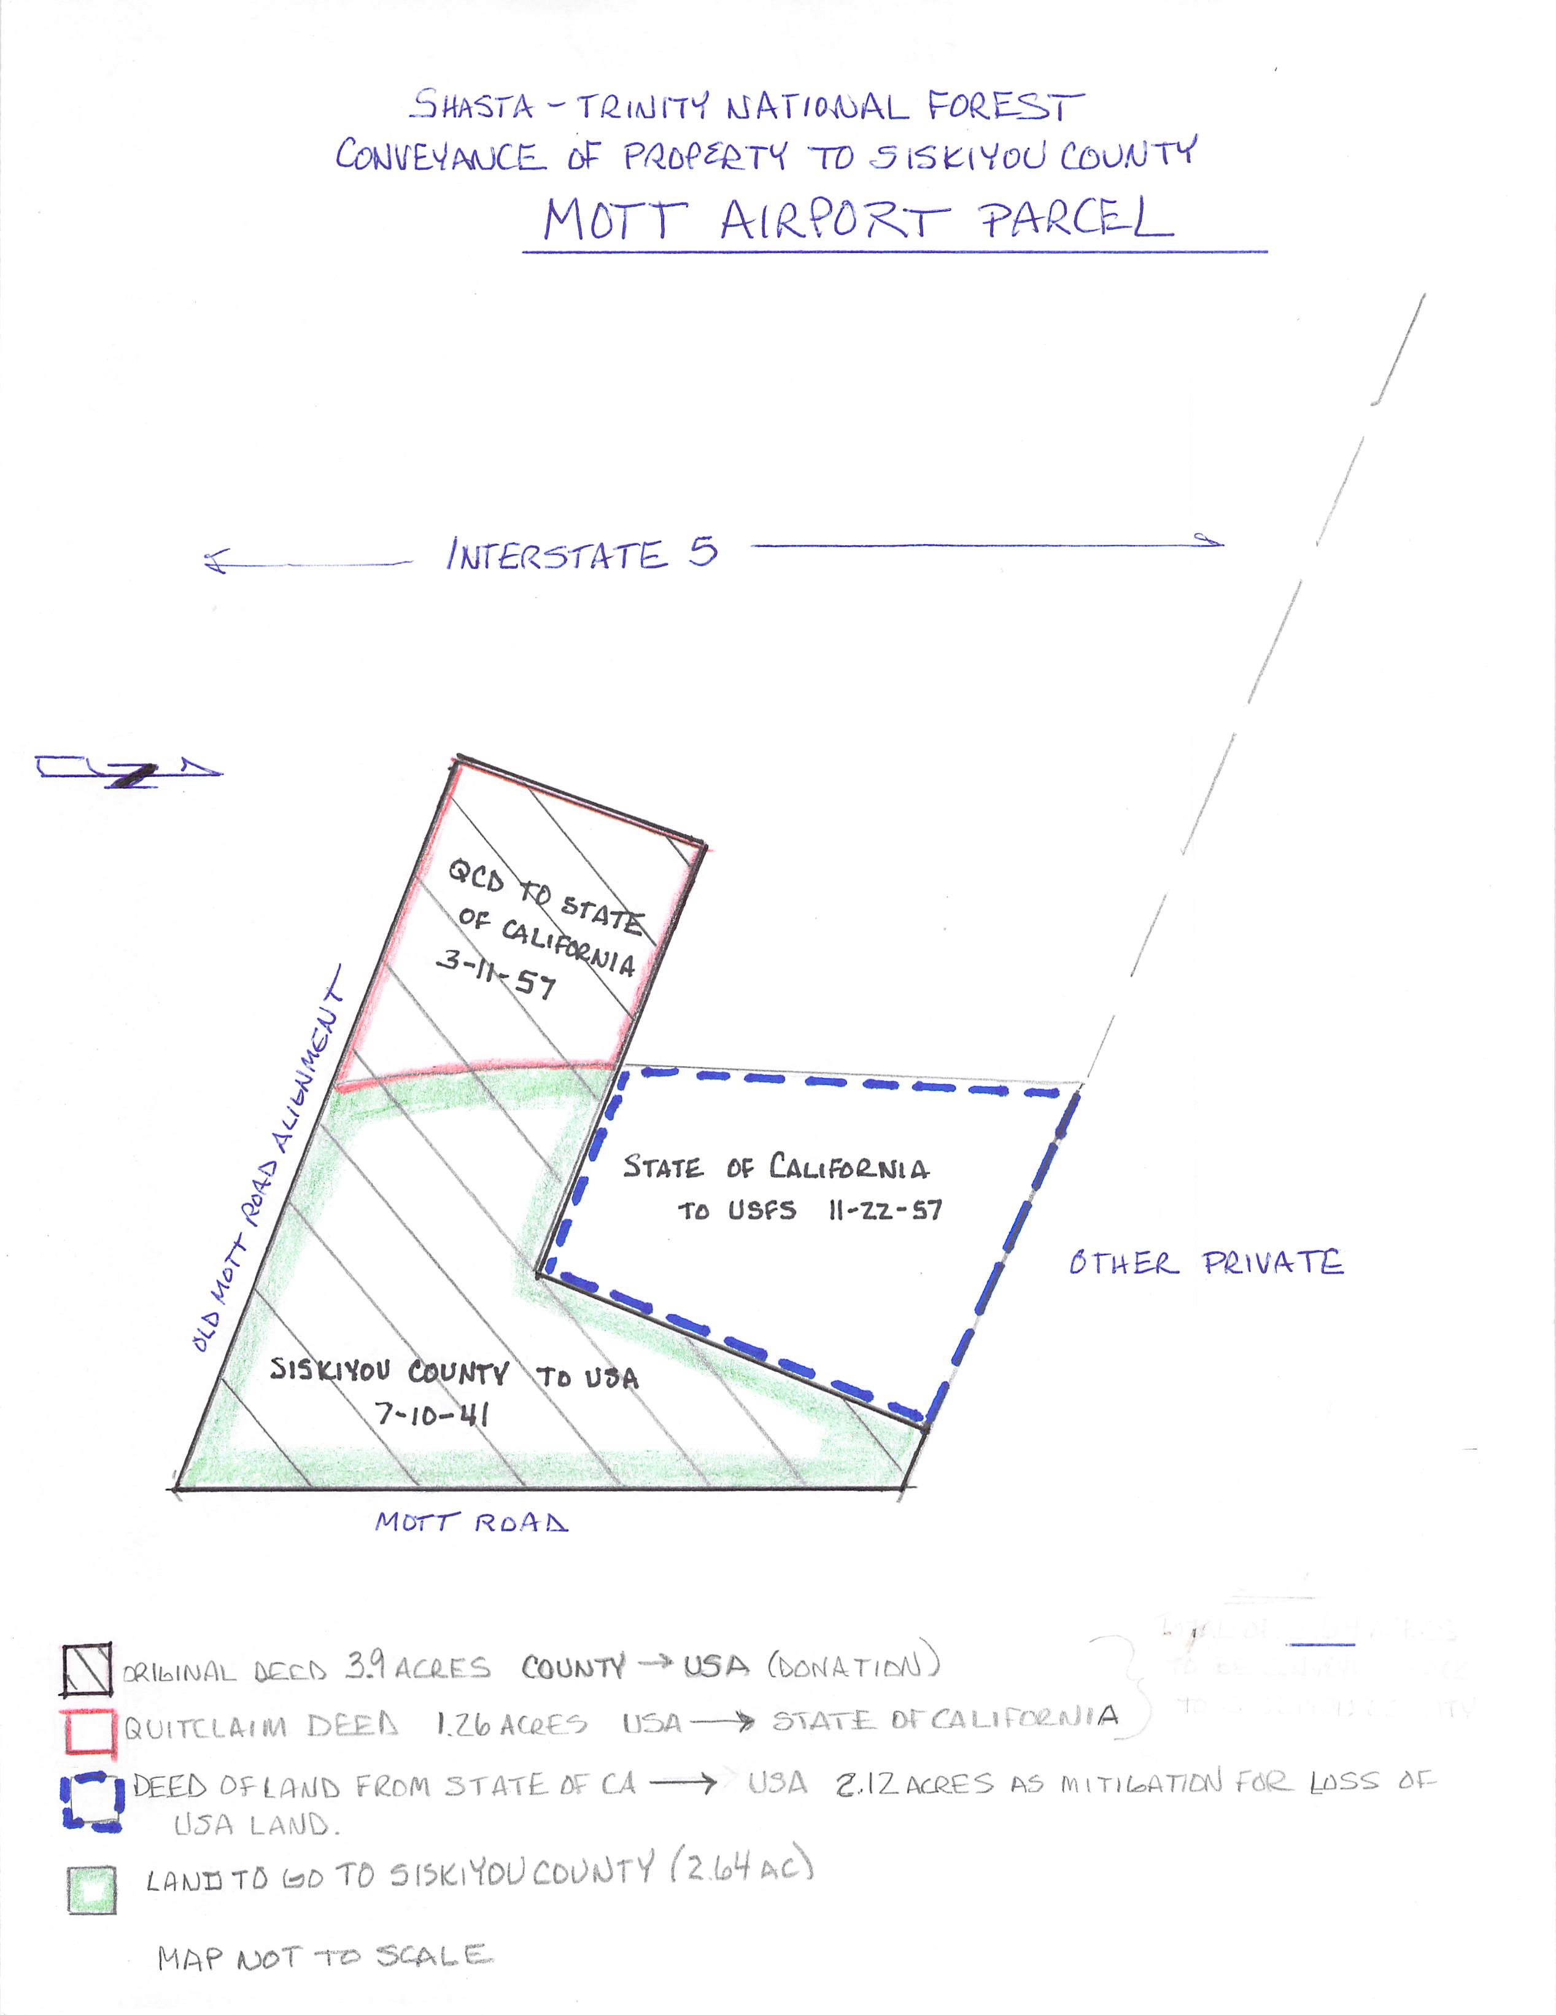
PROJECT MAP - MOTT AIRPORT PARCEL
Disposal of Property through GSA
Shasta-Trinity National Forest
Section 1, T.39N. R.4W. MDM
Original deed 3.9 acres from County of Siskiyou to USFS (Donation)
Quitclaim Deed of 1.26 acres from USFS to State of California
Land to be disposed by GSA. State of CA deed to USFS for 2.12 acres as mitigation

Land deeded to Siskiyou County (reversion) 2.64 acres

