Mott Campground Ownership and Occupancy Chronology

1940-01-27 Deed from Siskiyou County to USA (Recorded 7/10/41, Vol. 125, page 354 under Act of 3/3/25). Outside the Proclaimed boundary. Donation of 3.9 acres of land near Mott at the location of closed CCC camp. Donation to USA to provide for public camping opportunities along Highway 99. Deed reservation for easement for public road (State) and subject to reversionary rights if not used for NF purposes.
1940-05-18 Survey and map by U.S. Forest Service, Shasta National Forest Engineers of Mott Water System. Map indicates that water source was off of NFS from a source to the west and waterline crossed Mott Road to a water tank. Siskiyou County donation is shown in green below. The 2 additional parcels marked “US” are currently in private ownership or inside the Interstate 5 right-of-way. Note that Hwy 99 is now Mott Road.
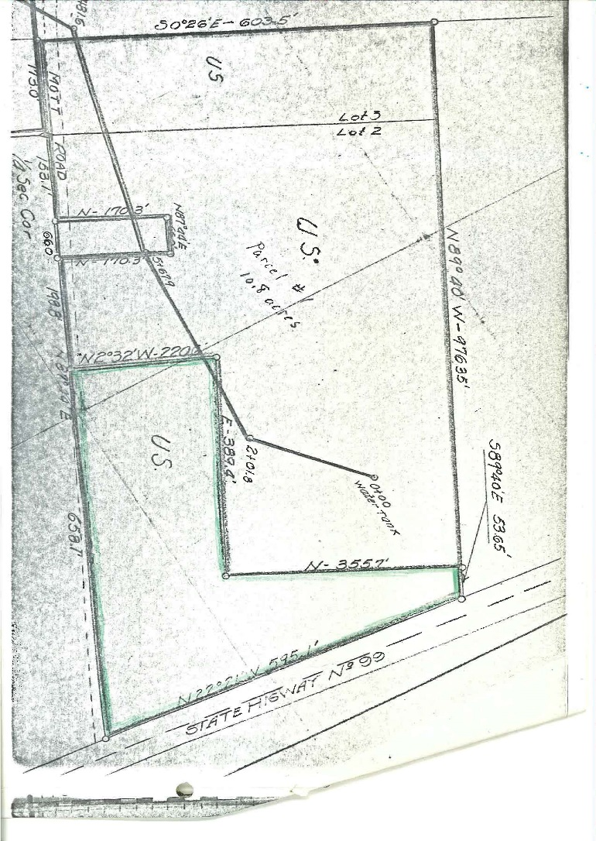

1952-04-02 Special Use Permit to State of California for a portion of NFS lands needed for highway purposes. No direct impacts to the campground. State begins construction to move Highway 99 from the east side of Mott parcel (bottom of map above) to the west side (crossing upper arm of green parcel). New alignment will cross a portion of the previously donated Siskiyou County land.
1957-02-07 Quit claim from USA to State of California (Recorded 3/11/57, Vol. 382 pg. 243 under the 1949 Act of Federal Property and Administrative Services). Quitclaim of 1.26 acres to State of California for upgrade and relocation of Highway 99 (marked in red on map below). Reservation to USA for minerals suitable for Atomic Energy. This quit claim includes the area permitted in 1952 and supersedes/terminates the permit.
1957-08-01 Directors Deed from State of California to USA (Recorded 11/22/57, Vol. 399, pg. 346 under Act of 3/3/25 as amended). Deed for 2.12 acres in lieu of 1.26 acres severed for highway ROW. Reservation for ingress/egress on western boundary. Marked in green crosshatch on map below.
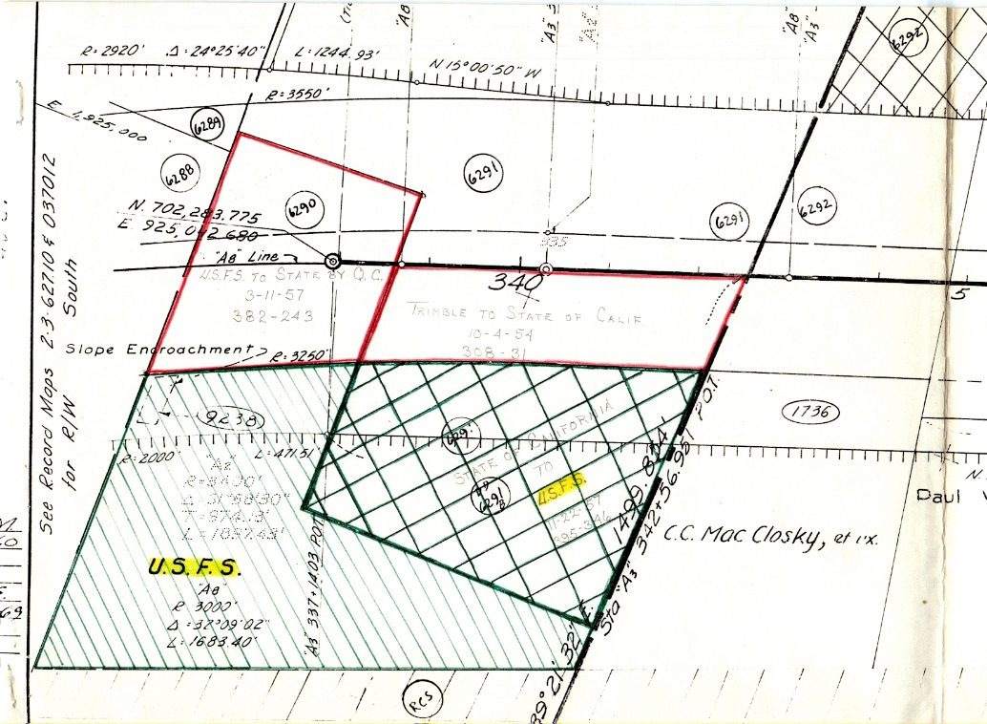
1972-05-18: Forest Service and State of California entered into an Agreement for Cooperative Work in anticipation of Caltrans work to widen Interstate 5 which will occupy an additional 1.2 acre portion of the NFS parcel at Mott (dark black box in map below) effectively closing the campground. The Agreement includes payment of $24,000 from State of California to USA for the value of the Mott Campground improvements for use by Forest Service to improve and expand an alternate site (Sims, Castle Crags, etc.). State and USA will pursue a Land Exchange for all remaining USA lands at Mott to be transferred to the State of California. Forest Service will issue a Special Use Permit for State water improvements in the interim until the land exchange is processed.
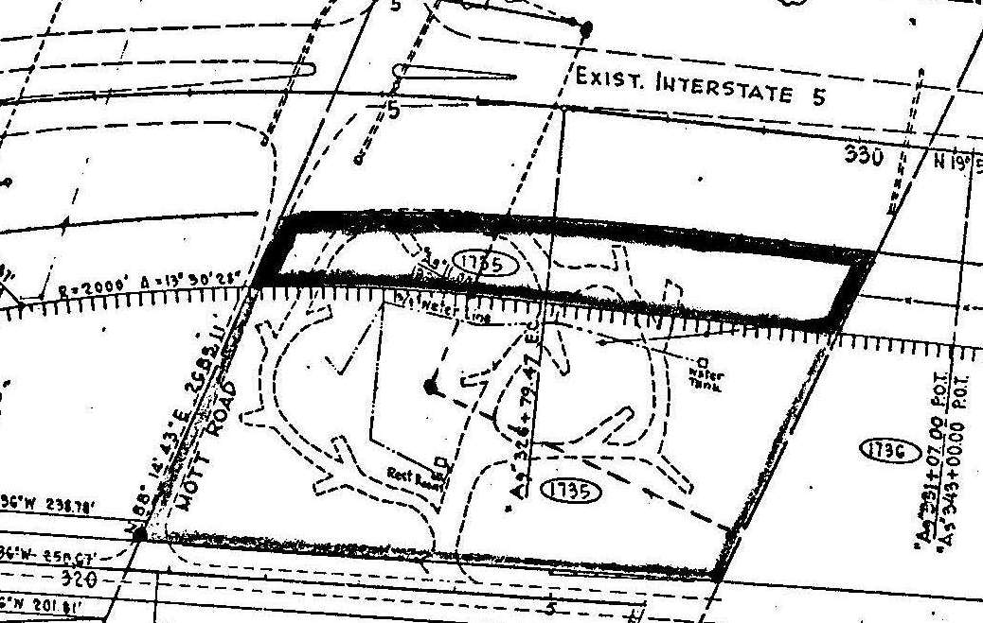

1972-05-09 Temporary Special Use Permit to State of California for authorization for a well with well housing, pump house, and connecting waterlines. Evidence from correspondence indicates that these improvements originally served the Agricultural Inspection Station located to the west of Interstate 5. Pacific Power also placed two small electrical boxes and buried a 240 kV powerline to the well. California Highway Patrol placed a propane tank at the site (use and pipes unknown).
1978 letters between State of California and Forest Service acknowledging that the Land Exchange has not been completed and is currently a low priority so improvements should continue to be authorized under Special Use Permit.
1979-02-02 Special Use permit to State of California for continued authorization of the improvements at the Mott campground site.

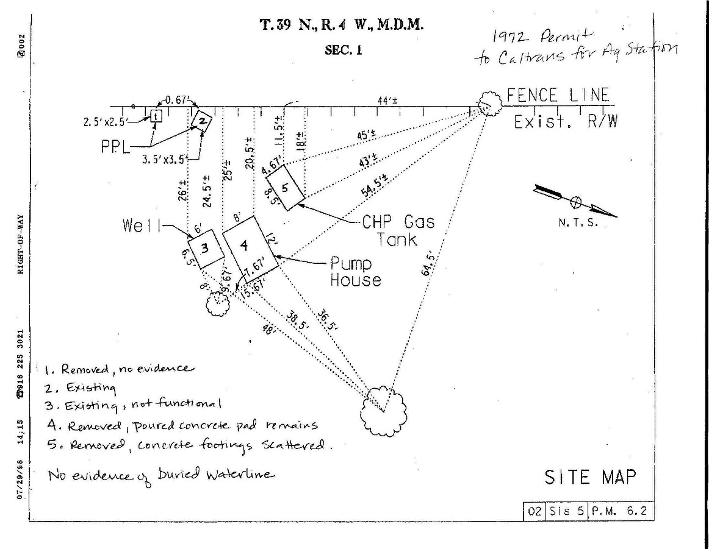

2000-12-12 Letter from State of California that a new water source for the Dunsmuir Grade Truck Inspection Facility (Agricultural Inspection Station was relocated north near Hilt) has been completed and requesting termination of the Special Use Permit.
2001-01-29 Reply from Forest Service asking for abandonment plan. No response.

