Exibit A

- Accept the following vehicle from the 10-33 program:

Cadillac Gage Commando V-150 M706

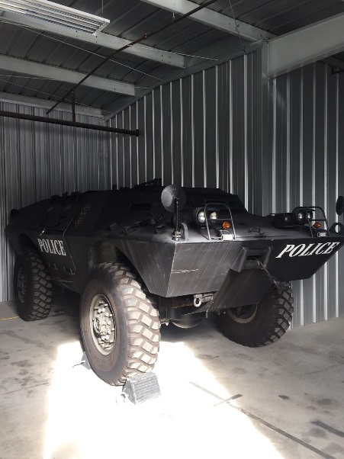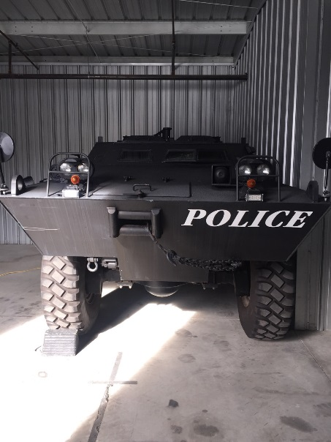

National Stock Number Serial Number
2320010747642 60614

ORIGINAL PROPERTY#: 13339CA091
ORIGINAL DTID#: H9DEB1-2228-0018

- Replacing the Following vehicle, returning it to the 10-33 program:

Unit 5163 Cadillac Gage Ranger Peacekeeper I

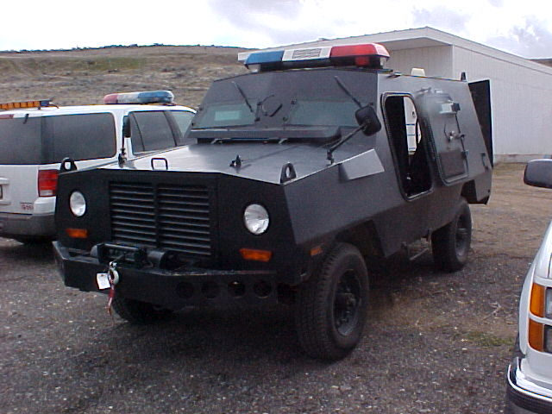

National Stock Number Serial # 50176
2320-01-074-7642

