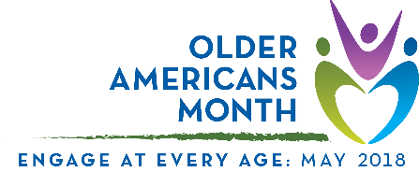

Proclamation

Older Americans Month 2018
A Proclamation
Whereas, Siskiyou County includes countless older Americans who enrich and strengthen our community; and

Whereas, Siskiyou County is committed to engaging and supporting older adults, their families, and caregivers; and

Whereas, we acknowledge the importance of taking part in activities that promote physical, mental, and emotional well-being—no matter your age; and

Whereas, Siskiyou County can enrich the lives of individuals of every age by:
- promoting home- and community-based services that support independent living;
- involving older adults in community planning, events, and other activities; and
- providing opportunities for older adults to work, volunteer, learn, lead, and mentor.

Now therefore, The Siskiyou County Board of Supervisors does hereby proclaim May 2018 to be Older Americans Month and urges every resident to take time during this month to recognize older adults and the people who serve them as vital parts of our community.

Passes and adopted this 1st day of May, 2018 by unanimous vote.

_____________________
Ray A. Haupt, Chair
ATTEST:
COLLEEN SETZER, COUNTY CLERK

________________________________

