Shasta River and South Fork Eel River Study Plan Tentative Schedule (DRAFT) 05/05/2017
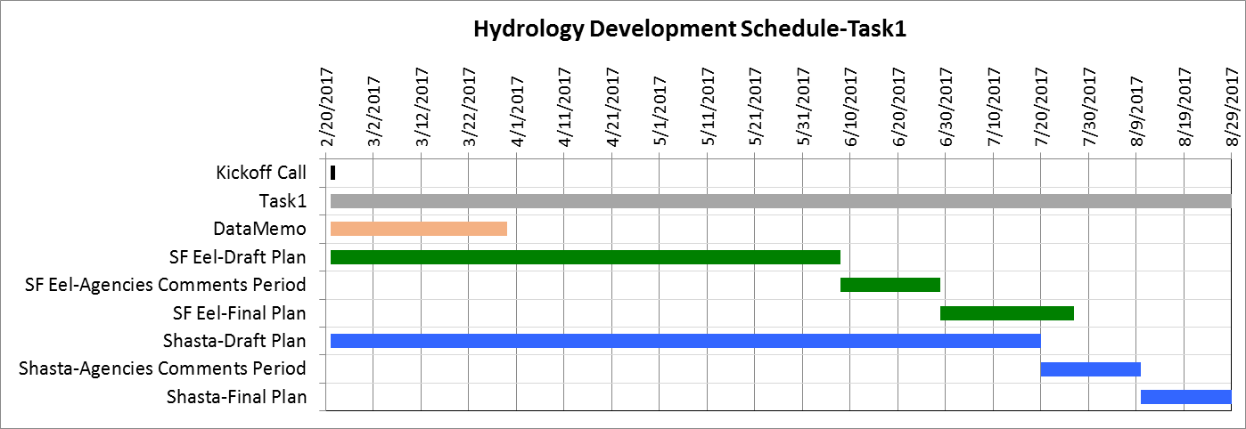
Deliverable | Due Date | #Working Days
South Fork Eel River Watershed
Data Compilation and Request Memo | 3/30/2017
Draft South Fork Eel Watershed Characterization/Study Plan | 6/8/2017
Comments due from Water Board (and study partners) - Draft South Fork Eel Watershed Characterization/Study Plan | 6/29/2017 | 16
Draft II South Fork Eel Watershed Characterization/Study Plan (incorporating comments) | 7/27/2017 | 20
Shasta River Watershed
Data Compilation and Request Memo | 3/30/2017
Draft Shasta Watershed Characterization/Study Plan | 7/20/2017
Comments due from Water Board (and study partners) - Draft Shasta Watershed Characterization/Study Plan | 8/10/2017 | 16
Draft II Shasta Watershed Characterization/Study Plan (incorporating comments) | 8/24/2017 | 11

